«APEC PETROTECHNIC HIGHER COLLEGE» LLP

«APPROVED»
Deputy director
for academic work
___________ Shakenova.A.E
"____" ____________2025 year

Educational-methodological complex of the subject

Module ПМ 01 «Maintenance and configuration of computer hardware and software»

Specialty: 06130100 – «Software»
Qualification: 4S06130105 – «Information Systems Technician»

Atyrau, 2025

«APEC PETROTECHNIC HIGHER COLLEGE» LLP
APPROVAL SHEET

Reviewed and approved at a meeting of the Methodological Council
Protocol № ____ of «____» ____________ 2025 y.

Considered at the meeting of the CMC Subject-Cycle Commission «Software»
Protocol № ____ of «____» ____________ 2025 y.

Chairperson of the Subject-Cycle Commission __________ A.E. Beket

Developer:
__________ D.M. Yermekov

Methodologist __________ A.K. Akhpanbetova

CONTENTS

No. | Title | Page
1. | Introduction | 4
2. | Academic Calendar | 6
3. | Glossary | 11
4. | Lecture Complex | 14
5. | Practical Classes | 75
6. | Laboratory Classes | 81
7. | Industrial Training | 87
8. | Independent Work Assignments for Students and Guidelines for Their Completion | 93
9. | List of Software and Multimedia Support for Classes | 97
10. | List of References | 98

INTRODUCTION

The module ПМ 01 «Maintenance and configuration of computer hardware and software» is designed to develop in students the practical skills required to operate, diagnose, maintain and repair personal computers, peripheral and office equipment. Students study occupational safety and electrical safety in IT-service enterprises, the architecture and circuitry of computer systems, the operation and monitoring of computers and peripherals, hardware diagnostics and troubleshooting, the recovery of equipment after failures, the replacement of consumables, and the management of internal and external devices of a personal computer.
The main goal of the module is to prepare a competent specialist (Information Systems Technician) capable of independently assembling, configuring, servicing and repairing computer hardware, ensuring its stable operation and prolonging its service life. Special attention is paid to hands-on production training: replacing consumables and managing PC devices in a workshop environment.
Upon completion of the module the student should KNOW: occupational and electrical safety norms; the architecture and circuitry of computer systems; the operating principles of computers and peripheral devices; methods of hardware diagnostics and fault isolation; procedures for recovery after failures; types of consumables and the rules for their replacement.
The student should BE ABLE TO: comply with safety requirements; determine the operability of computer systems at the circuit level; operate and monitor computers and peripherals; diagnose and eliminate hardware faults; restore equipment after failures and prevent them; replace consumables; and manage the internal and external devices of a personal computer.
The student should be PROFICIENT in the tools and instruments of hardware diagnostics and repair (multimeter, POST-card, diagnostic software), in assembly and configuration of personal computers, in the maintenance of peripheral and office equipment, and in the safe and documented replacement of consumables.
Prerequisites of the module: basic computer literacy and the general-education modules of the first year. Post-requisites: ПМ 02 «Installation and configuration of operating systems». The module is studied in the 3rd semester and has a total volume of 258 hours (theory 150 h + industrial training 108 h).

Module assessment weights
Type of assessment | Form | Weight, %
Current control (theory) | Oral questioning, self-assessment questions | 15%
Laboratory and practical work | Completion and defence of works | 20%
Industrial (production) training | Workshop tasks, practical skills | 25%
Intermediate certification (exam) | Examination on the module questions | 40%
Total |  | 100%

I. ACADEMIC CALENDAR

Module: ПМ 01 «Maintenance and configuration of computer hardware and software»
Specialty: 06130100 – «Software»
Semester: 3
Total hours of the module – 258 (theory 150 + industrial training 108)

No. | Name of topics | Date of lesson | Type of activity
1. | Introduction to the Module. Organising the Workplace of a Computer Hardware Service Specialist |  | Learning new material
2. | Regulatory and Legal Framework of Labour Safety and Occupational Health in Information-Service Enterprises |  | Learning new material
3. | Electrical Safety and Fire Safety When Working with Computing Equipment |  | Learning new material
4. | Protection Against Static Electricity, Personal Protective Equipment and Sanitary Norms |  | Learning new material
5. | Personal Computer Architecture and Interaction of the Main Units |  | Learning new material
6. | The Motherboard: Chipset, Buses, Connectors and Expansion Slots |  | Learning new material
7. | Digital Circuitry: Logic Gates, Flip-Flops and Adders |  | Learning new material
8. | The PC Power Subsystem: Power Supply, VRM Circuits and Voltage Generation |  | Learning new material
9. | Memory and Clocking Subsystems: RAM, Frequency Generators, Data and Address Buses |  | Learning new material
10. | Test and Measurement Instruments and Methods for Checking Signals on a Board |  | Learning new material
11. | Reading Schematic and Block Diagrams to Assess Unit Operability |  | Learning new material
12. | Rules of Computer Operation and Operating Modes of Computing Equipment |  | Learning new material
13. | Peripheral Devices: Classification, Interfaces and Connection Principles |  | Learning new material
14. | Monitoring the State of Equipment: Temperature, Load and Event Logs |  | Learning new material
15. | Preventive Maintenance and Extending the Service Life of Equipment |  | Learning new material
16. | Classification of Hardware Faults and Their Typical Symptoms |  | Learning new material
17. | Diagnostic Methods: Visual Inspection, POST Diagnostics and the Substitution Method |  | Learning new material
18. | Software Diagnostic Tools and Testing of Hardware Components |  | Learning new material
19. | Resolving Typical Component Faults and the Order of Repair Operations |  | Learning new material
20. | Causes and Classification of Hardware and Software Failures |  | Learning new material
21. | Recovery of BIOS/UEFI, Firmware and System Software |  | Learning new material
22. | Backup, Data Recovery and System Imaging |  | Learning new material
23. | Failure Prevention: Power Stabilisation, Cooling, Updates and Monitoring |  | Learning new material
24. | Types of consumables used in computing and office equipment |  | Learning new material
25. | Consumables of printing devices: cartridges, toner, ink and photoconductor drums |  | Learning new material
26. | Procedures for replacing, accounting for and disposing of consumables |  | Learning new material
27. | Organizing a safe workspace and using PPE during PC disassembly |  | Skills development lesson
28. | Drilling responses to electric shock and equipment fire |  | Skills development lesson
29. | Measuring power-supply voltages with a multimeter |  | Skills development lesson
30. | Checking motherboard circuits and locating a short circuit |  | Skills development lesson
31. | Diagnostics by POST codes and serviceability check on a test bench |  | Skills development lesson
32. | Comprehensive assessment of system serviceability at the circuit level |  | Skills development lesson
33. | Connecting and configuring peripheral devices |  | Skills development lesson
34. | Monitoring PC operation with utilities and preparing a report |  | Skills development lesson
35. | Diagnosing a PC fault and localizing the defective unit |  | Skills development lesson
36. | Repairing a hardware fault and verifying restored serviceability |  | Skills development lesson
37. | Restoring system operability after a software failure |  | Skills development lesson
38. | Recovery after a hardware failure and evaluation of preventive measures |  | Skills development lesson
39. | Removing and installing inkjet printer cartridges, cleaning print heads and running a test print |  | Industrial training
40. | Replacing and refilling a laser printer cartridge, cleaning the drum and toner transfer unit |  | Industrial training
41. | Installing and aligning color MFP toner cartridges, calibrating color reproduction from a test page |  | Industrial training
42. | Replacing the fuser film and rubber pressure roller of a laser printer fusing unit |  | Industrial training
43. | Servicing a dot-matrix printer: replacing the ink ribbon and adjusting the print-head gap |  | Industrial training
44. | Comprehensive replacement of office-equipment consumables with maintenance of a consumables log |  | Industrial training
45. | Disassembling and assembling the system unit, identifying and removing internal PC devices |  | Industrial training
46. | Installing and connecting RAM modules, verifying operation in dual-channel mode |  | Industrial training
47. | Mounting HDD/SSD drives and an optical drive, connecting via SATA and power interfaces |  | Industrial training
48. | Installing a discrete graphics card, connecting auxiliary power and configuring drivers |  | Industrial training
49. | Configuring BIOS/UEFI parameters: boot order, storage modes and temperature monitoring |  | Industrial training
50. | Connecting and configuring external output devices: monitor, projector and a second display |  | Industrial training
51. | Connecting USB peripherals: printer, scanner, webcam, installing and verifying drivers |  | Industrial training
52. | Configuring keyboard, mouse and input devices, checking response and hotkeys |  | Industrial training
53. | Installing and configuring the audio subsystem: speakers, headphones, microphone, checking channels |  | Industrial training
54. | Configuring the network adapter and connecting to the local network, checking access to shared resources |  | Industrial training
55. | Managing PC device power and configuring power-saving modes |  | Industrial training
56. | Complete assembly and configuration of a workstation with all internal and external devices connected |  | Industrial training

II. GLOSSARY
The glossary contains the main definitions, terms and concepts that reflect the core content of the module. It is arranged in alphabetical order.

Term | Definition
Backup | A copy of data stored separately from the original so it can be restored after loss, corruption, or hardware failure.
Beep code | A pattern of audible signals emitted by the motherboard during POST to indicate a hardware fault when no video output is available.
BIOS | Basic Input/Output System, the firmware on the motherboard that initializes hardware at startup and hands control to the operating system.
Bus | A communication pathway that transfers data between components of a computer, such as the system bus, PCIe bus, or USB.
Cache | Small, fast memory located close to the CPU that stores frequently used data to speed up processing.
Cartridge | A replaceable consumable container holding ink or toner that supplies a printer during the printing process.
Chipset | A set of integrated circuits on the motherboard that manages data flow between the CPU, memory, storage, and peripherals.
Connector | A physical interface, such as SATA, USB, HDMI, or a power plug, used to join cables and components together.
CPU | Central Processing Unit, the main chip that executes instructions and performs the calculations of a computer.
Diagnostics | The systematic process of testing hardware and software to identify the cause of a fault or malfunction.
Driver | Software that allows the operating system to communicate with and control a specific hardware device.
ESD | Electrostatic discharge, a sudden flow of static electricity between objects that can damage sensitive electronic components.
ESD wrist strap | An antistatic band worn on the wrist and grounded to safely dissipate static charge while handling components.
Firmware | Permanent software embedded in a hardware device that controls its low-level functions, such as BIOS/UEFI or an SSD controller.
Form factor | The standardized physical size, shape, and layout of a component, such as ATX motherboards or 2.5-inch drives.
GPU | Graphics Processing Unit, a specialized processor that renders images, video, and graphics output to a display.
Grounding | Connecting equipment to earth or a common reference point to safely discharge static and prevent electric shock.
HDD | Hard Disk Drive, a magnetic storage device that stores data on spinning platters read by moving heads.
Heat sink | A passive metal component that absorbs and dissipates heat away from the CPU or other chips to prevent overheating.
Jumper | A small connector that bridges pins on a board to configure hardware settings, such as clearing the CMOS.
Motherboard | The main printed circuit board that connects and allows communication between the CPU, memory, storage, and peripherals.
Multimeter | A test instrument used to measure voltage, current, and resistance when diagnosing electrical faults.
Northbridge | A legacy motherboard chip that handled high-speed communication between the CPU, RAM, and graphics.
Overheating | A condition where a component exceeds its safe operating temperature, causing throttling, instability, or damage.
Peripheral | An external device connected to a computer, such as a keyboard, mouse, printer, scanner, or monitor.
POST | Power-On Self-Test, a diagnostic routine run by the firmware at startup to verify that essential hardware is working.
PSU | Power Supply Unit, the component that converts mains AC electricity into the regulated DC voltages used by the computer.
RAID | Redundant Array of Independent Disks, a method of combining multiple drives for improved performance, redundancy, or both.
RAM | Random Access Memory, fast volatile memory that temporarily holds data and programs the CPU is actively using.
SATA | Serial ATA, the standard interface used to connect storage drives such as HDDs and SSDs to the motherboard.
SMART | Self-Monitoring, Analysis and Reporting Technology, a system in drives that monitors health and predicts impending failure.
SMPS | Switched-Mode Power Supply, an efficient power supply design used in PSUs to convert and regulate voltage.
Socket | The mechanical mount on a motherboard, such as an LGA or AM socket, into which the CPU is installed.
Southbridge | A legacy motherboard chip that managed lower-speed input/output devices, storage, and peripheral buses.
SSD | Solid State Drive, a storage device that uses flash memory with no moving parts for fast, durable data access.
Static electricity | An imbalance of electric charge on a surface that can discharge suddenly and harm electronic components.
Thermal paste | A conductive compound applied between a chip and its heat sink to improve heat transfer.
Thermal throttling | An automatic reduction of a component's speed to lower temperature and prevent damage from overheating.
Toner | A fine powder used by laser printers and copiers that is fused onto paper to form text and images.
Troubleshooting | A structured problem-solving approach used to locate, isolate, and correct hardware or software faults.
UEFI | Unified Extensible Firmware Interface, the modern replacement for BIOS providing faster boot, larger disks, and a graphical setup.
UPS | Uninterruptible Power Supply, a battery-backed device that supplies temporary power and protects equipment during outages.
USB | Universal Serial Bus, a standard interface for connecting peripherals and transferring data and power.
Voltage | The electrical potential difference, measured in volts, that drives current through a circuit.
Wattage | The amount of electrical power, measured in watts, that a device consumes or a power supply can deliver.

III. LECTURE COMPLEX

Lecture No. 1
Topic: Introduction to the Module. Organising the Workplace of a Computer Hardware Service Specialist
Plan:
1. Purpose, structure and learning outcomes of the module
2. Ergonomic and technical requirements for a service workstation
3. Tools, documentation and order at the repair bench

This module, "Maintenance and configuration of computer hardware and software", prepares the software-specialty student to keep computing equipment in working order safely and efficiently. The first learning outcome, labour safety and occupational health, comes before any diagnostics or repair for a simple reason: a technician who injures himself, damages a board, or starts a fire cannot serve a client. The module is built around six learning outcomes that move from safety, through circuit-level diagnostics, operation and monitoring, fault finding, recovery, and finally the replacement of consumables. Each outcome combines theory lessons, laboratory practical work, and independent study, so the learner both understands the principles and demonstrates them on real equipment.
An information-service enterprise is any organisation whose work depends on continuously running computers, servers, networks and office equipment: a bank branch, a government service centre, a school computer class, a data-processing department. The hardware service specialist installs, maintains, diagnoses and repairs this equipment. Because the work touches mains electricity, sharp metal edges, hot components and electrostatically sensitive parts, the workplace itself must be designed so that hazards are controlled before a task begins. Good workplace organisation is not housekeeping for its own sake; it is the first and cheapest layer of accident prevention.
A properly organised service workstation has several non-negotiable features. The bench must be stable, have a non-conductive or grounded anti-static surface, and provide enough free area for a fully disassembled computer plus tools. Lighting should be even, shadow-free and around 300 to 500 lux at the work surface so that small markings on chips and tiny screws are clearly visible. The chair must be height-adjustable to support an upright posture, and the monitor used for testing should sit roughly at eye level and an arm's length away. Mains sockets should be supplied through a protective earth and ideally through a residual-current device, and cables must be routed so that nobody can trip over them.
Ergonomics protects the technician over the long term. Continuous sitting, repetitive movements and screen work cause musculoskeletal strain, eye fatigue and reduced concentration, and a tired technician makes mistakes that damage hardware. The standard countermeasures are an adjustable chair with lumbar support, feet flat on the floor or on a footrest, forearms roughly horizontal at the keyboard, the top of the screen at or just below eye level, and regular short breaks, commonly five to ten minutes after each hour of intensive work. Following the 20-20-20 habit, looking about twenty feet away for twenty seconds every twenty minutes, relaxes the eye muscles and reduces visual strain.
Tools and materials must each have a defined place. A basic service kit includes Phillips and flat screwdrivers of several sizes, anti-static tweezers, a plastic spudger or pry tool, a soft brush, thermal paste, cable ties, an anti-static wrist strap and mat, a multimeter, and small labelled containers for screws. Keeping screws sorted by the unit they came from, and photographing connectors before unplugging them, prevents the most common reassembly errors. Liquids, food and drinks are forbidden at the bench because a spill onto a powered board causes short circuits and corrosion.
Order and discipline at the workplace directly reduce risk. The widely used "5S" approach, sort, set in order, shine, standardise, sustain, removes unnecessary items, gives every tool a home, keeps the surface clean of dust and solder debris, fixes a standard layout, and makes tidiness a daily habit. A clean bench means fewer lost screws, fewer scratched boards, less dust contaminating fans and heatsinks, and a clear path for the technician to react quickly if something goes wrong.
Documentation is part of workplace organisation too. Before starting, the specialist should have the device's service manual or at least its specifications, the client's request or work order, and a place to record what was done. Recording the initial condition, the actions taken and the result protects both the client and the technician, supports warranty decisions, and builds a maintenance history that helps predict future failures. Working without documentation leads to repeated mistakes and disputes.
Common beginner mistakes set the tone for the whole module: starting disassembly without powering down and unplugging the unit, piling tools and parts in a heap, neglecting anti-static measures, ignoring lighting and posture, and failing to label cables and screws. Each of these is cheap to avoid and expensive to correct. By the end of this introductory topic the learner should be able to describe the structure of the module, list the requirements for a safe and ergonomic service workstation, and set up a bench that is ready for safe disassembly and repair of a personal computer.
CL: /1/.
Self-assessment questions:
1. What is an information-service enterprise, and what role does the hardware service specialist play in it?
2. List the main technical and ergonomic requirements for a computer service workstation.
3. How does the 5S method reduce the risk of accidents and hardware damage at the bench?
4. Why are food and liquids prohibited at the repair workstation?
5. Which documents should a specialist prepare before starting work on a client's computer, and why?

Lecture No. 2
Topic: Regulatory and Legal Framework of Labour Safety and Occupational Health in Information-Service Enterprises
Plan:
1. Hierarchy of labour-safety law: codes, standards and local rules
2. Duties of the employer and the employee
3. Instruction briefings, accident investigation and records

Labour safety is not a matter of personal preference; it is governed by a structured body of law and standards that every enterprise must follow. The framework is hierarchical. At the top stands the national Labour Code, which establishes the right to safe working conditions and the general duties of employers and workers. Below it come government regulations and sanitary rules, then technical standards such as GOST and the international ISO and IEC series, and finally the enterprise's own internal documents: safety instructions, job descriptions and local orders. A higher-level rule always overrides a lower one, and the local instruction must never contradict the law above it.
The Labour Code of the Republic of Kazakhstan obliges the employer to provide safe equipment, protective means, training and medical checks, and gives the employee the right to refuse work that threatens life or health. Occupational safety, or "охрана труда", is defined as a system of legal, socio-economic, organisational, technical, sanitary-hygienic and treatment-and-prevention measures that preserve the health and working capacity of people during work. Understanding this definition matters because it shows that safety is a system, not a single rule: it covers documents, equipment, the environment, medical care and behaviour together.
Technical standards translate the law into concrete numbers and procedures. The GOST 12 "System of Labour Safety Standards" series, for example, classifies dangerous and harmful production factors and sets requirements for electrical safety and for work with display equipment. Sanitary rules and norms, the SanPiN documents, define limits for illumination, noise, microclimate, electromagnetic fields and the area and air volume per workstation. ISO 45001 describes a modern occupational health and safety management system based on continual risk assessment. For an IT-service enterprise these standards specify, among other things, the minimum floor area per computer workstation, acceptable screen-radiation limits, and the rules for earthing electrical equipment.
Hazards in the workplace are classified as physical (electric current, noise, vibration, high or low temperature), chemical (toner dust, cleaning solvents, fumes from overheated plastics), and psychophysiological (eye strain, monotony, mental overload). Classifying a hazard is the first step toward controlling it, because each class has its own established countermeasures: insulation and earthing for electrical hazards, ventilation and respirators for chemical ones, breaks and task rotation for psychophysiological ones.
The employer carries clearly defined duties: to organise safe workplaces, to supply certified protective equipment free of charge, to arrange safety training and knowledge tests, to provide preliminary and periodic medical examinations, and to investigate and record every accident. The employee, in turn, must comply with safety instructions, use the protective means provided, undergo training and medical checks, and immediately report any dangerous situation or accident. Safety is therefore a shared obligation; neglect by either side breaks the system.
A central mechanism of the framework is the system of safety briefings, the "инструктаж". The introductory briefing is given to every newcomer on the first day. The primary briefing at the workplace explains the specific hazards of the job. Repeated briefings refresh this knowledge at fixed intervals, usually every three to six months. Unscheduled briefings follow changes in equipment or rules or after an accident, and a targeted briefing precedes one-off hazardous tasks. Every briefing is logged in a register and signed by both the instructor and the worker; an unsigned register means, in legal terms, that the briefing never happened.
When an accident does occur, the law prescribes a fixed procedure: give first aid and call medical help, preserve the scene if it is safe to do so, notify the employer, and form a commission to investigate the causes. The findings are written up in a formal report, the causes are analysed, and corrective measures are introduced to prevent recurrence. This investigation discipline turns individual accidents into lessons for the whole organisation and is itself a legal requirement, not an optional courtesy.
Responsibility for breaches of labour-safety law can be disciplinary, administrative, material or, in serious cases, criminal. For the technician, the practical message is concrete: know which instruction applies to your task, work strictly within it, sign and respect the briefing register, use the protective equipment that the employer is legally obliged to provide, and report hazards instead of working around them. A common mistake is treating safety paperwork as a bureaucratic formality; in reality those documents define exactly who is protected, who is liable, and what must be done when something goes wrong. By the end of this topic the learner should be able to name the main regulatory documents on labour safety and explain the duties they impose on both employer and worker.
CL: /1/.
Self-assessment questions:
1. Describe the hierarchy of labour-safety documents from the Labour Code down to the enterprise instruction.
2. How is occupational safety ("охрана труда") defined, and why is it called a system?
3. List the types of safety briefing and state when each one is given.
4. What duties does the law place on the employer, and what duties on the employee?
5. What actions are required when an accident occurs at the workplace?

Lecture No. 3
Topic: Electrical Safety and Fire Safety When Working with Computing Equipment
Plan:
1. Effects of electric current and rules of electrical safety
2. Protective earthing, insulation and de-energising before work
3. Causes of fire in IT equipment and fire-fighting measures

Computing equipment runs on mains electricity, so electrical safety is the most critical part of labour protection in hardware service. Electric current passing through the human body can cause muscular contraction, burns, disruption of breathing, and ventricular fibrillation of the heart. The severity depends on the current's magnitude, its path through the body, the duration of contact, the frequency, and the person's condition. A current of around 0.5 to 1.5 milliamperes at 50 hertz is merely perceptible; about 10 to 15 milliamperes already causes muscles to lock so the victim cannot let go; and roughly 100 milliamperes flowing through the chest for a second can be fatal. Because the human body's resistance falls sharply when the skin is moist, even nominally low voltages become dangerous in damp conditions.
Voltage classes matter for risk assessment. Mains voltage of 220 volts is lethal and must always be treated as dangerous. The low internal voltages of a computer, 3.3, 5 and 12 volts from the power supply, are safe to touch, but the primary side of the power-supply unit and the mains cable carry full mains voltage, and the capacitors inside a switched-mode power supply can hold a dangerous charge for minutes after it is unplugged. For this reason a power-supply unit is repaired only by qualified personnel and is never opened casually by a student.
The fundamental rule of electrical safety in hardware service is simple and absolute: de-energise before working. Shut down the operating system, switch off the power supply, and unplug the mains cable from the socket before opening the case or touching internal components. Switching off at the front button alone is not enough, because standby voltage is still present on the motherboard. After unplugging, pressing the power button once discharges residual energy. Only then is it safe to work inside the machine.
Three technical measures protect against electric shock. Protective earthing connects the metal chassis to ground so that, if a live wire touches the case, the fault current flows to earth and trips the protection instead of passing through a person. Insulation, the intact plastic and varnish around conductors, keeps current confined to its intended path; cracked or frayed cables must be replaced, never taped over. A residual-current device, or RCD, monitors the balance between live and neutral currents and cuts the supply within milliseconds if some current leaks through a body to earth. Together with fuses and circuit breakers that protect against overload and short circuit, these measures form the protective system around every workstation.
Safe practice also depends on tools and habits. The technician uses screwdrivers and pliers with insulated handles, keeps one hand away from earthed metal when probing live circuits, never works on energised mains equipment alone, and never uses damaged plugs, sockets or extension leads. Overloading a socket by daisy-chaining several high-power devices is a frequent and dangerous mistake, because the accumulated current overheats the wiring. Equipment showing scorch marks, a burning smell or a tripping breaker must be taken out of service immediately.
Fire safety is the second pillar of this topic, because electrical faults are a leading cause of fire in IT environments. Typical causes are short circuits, overloaded sockets and extension leads, poor contacts that overheat, failed cooling that lets components reach ignition temperature, dust accumulation inside power supplies, and faulty or counterfeit chargers and batteries, especially lithium-ion cells that can swell and ignite. The fire triangle, fuel, heat and oxygen, explains prevention: remove any one side and the fire cannot start or continue. In practice that means controlling heat sources, keeping equipment clean and well ventilated, and not surrounding live equipment with combustible clutter.
Energised electrical equipment must never be extinguished with water or foam, because water conducts electricity and would expose the operator to shock and spread the fault. The correct extinguishing agents are carbon-dioxide (CO2) or dry-powder extinguishers, which do not conduct and leave little residue; CO2 is preferred for electronics because it does not damage boards. The standing rule is to de-energise first if it can be done safely, then extinguish. Server rooms are additionally protected by automatic gaseous suppression systems and smoke detectors. Every technician must know the location of the nearest extinguisher and emergency power cut-off and how to use them.
If a person is being shocked, the rescuer must first break the contact safely, by switching off the supply or pushing the victim clear with a dry, non-conductive object such as a wooden stick, never with bare hands. Once contact is broken, the rescuer checks breathing and pulse, calls emergency services, and begins cardiopulmonary resuscitation if needed. The most dangerous mistakes in this topic are working on equipment that is still plugged in, ignoring the charge stored in power-supply capacitors, using water on an electrical fire, and grabbing a shock victim directly. By the end of the topic the learner should be able to apply the rules of electrical and fire safety and explain the correct response to electric shock and to equipment catching fire.
CL: /1/.
Self-assessment questions:
1. How does electric current affect the human body, and which current levels are considered dangerous?
2. Explain the rule "de-energise before working" and why switching off the front button is not sufficient.
3. What do protective earthing, insulation and a residual-current device each protect against?
4. Why must water never be used on energised electrical equipment, and which extinguishers are correct?
5. Describe the correct sequence of actions when a person is being electrocuted.

Lecture No. 4
Topic: Protection Against Static Electricity, Personal Protective Equipment and Sanitary Norms
Plan:
1. Electrostatic discharge: how it damages components and how to prevent it
2. Personal protective equipment for hardware service
3. Sanitary and hygienic norms for the IT workplace

Static electricity is invisible and silent, yet it destroys more computer components in service work than any dramatic fault. Electrostatic discharge, or ESD, is the sudden flow of charge between two objects at different electrical potentials. A person walking across a synthetic carpet can accumulate several thousand volts; touching a circuit board then sends a tiny but intense spark through the chips. People begin to feel a discharge only at about 3000 volts, but sensitive components such as memory, processors, MOSFETs and chipset chips can be damaged at a few tens or hundreds of volts. This means a board can be ruined by a discharge the technician never even feels.
ESD damage takes two forms, and both are dangerous. A catastrophic failure destroys the component immediately, and the fault is obvious. A latent failure only weakens the internal structure; the device still works at first but fails unpredictably weeks or months later. Latent damage is the more insidious because it produces intermittent faults that are extremely hard to diagnose and that erode the reputation of the service. The lesson is that anti-static discipline must be constant, not reserved for components that visibly matter.
Preventing ESD relies on equalising potentials and draining charge safely to ground. The core tools are the anti-static wrist strap, which connects the technician's wrist through a one-megohm resistor to earth so charge bleeds away slowly and safely; the anti-static mat on which the work is performed; and earthed equipment. The resistor in the strap is essential: it protects the person from electric shock while still draining static. Components are stored and carried in anti-static bags, the dissipative metallised type, never ordinary plastic, which itself generates charge. Before touching a board the technician should momentarily touch an earthed metal part of the chassis to equalise potential.
Good ESD habits reinforce the equipment. The technician holds boards by their edges and avoids touching connector pins, contacts and chip legs; keeps humidity in the room at a moderate level, since very dry air greatly increases static build-up; avoids synthetic clothing and woollen jumpers; and refrains from sliding components across surfaces. A frequent and costly mistake is to wear a wrist strap that is not actually clipped to ground, which gives a false sense of safety while protecting nothing. Anti-static measures cost very little and prevent failures that are otherwise almost impossible to trace.
Personal protective equipment, or PPE, shields the technician from the remaining physical and chemical hazards of the job. The anti-static wrist strap and heel straps guard the equipment; for the person, the relevant items include protective gloves when handling sharp sheet-metal edges, safety glasses when blowing out dust or working near springs and small flying parts, and a dust mask or respirator when cleaning toner and accumulated dust from printers and power supplies, because fine toner particles are harmful to the lungs. When soldering, eye protection and adequate ventilation or fume extraction are required to avoid inhaling flux fumes. PPE must be in good condition and used correctly; a torn glove or a respirator worn loosely gives only the illusion of protection.
Sanitary and hygienic norms define the environment in which all this work takes place, and they exist because a poor environment slowly undermines health and concentration. The norms set a minimum floor area, commonly about 4.5 square metres, and an air volume of roughly 15 to 20 cubic metres per workstation that uses a display, together with a comfortable microclimate of about 21 to 25 degrees Celsius and relative humidity in the 40 to 60 per cent range. Such humidity is doubly useful, because it is comfortable for people and simultaneously suppresses static build-up.
Lighting, noise and screen ergonomics complete the sanitary picture. Workplace illumination should be even and around 300 to 500 lux, arranged to avoid glare and reflections on screens, which cause eye strain and headaches. Noise from fans and equipment should be kept within hygienic limits so that it does not impair concentration. Workstations are spaced so that operators are not exposed to the rear of neighbouring monitors, and regulated breaks, typically a short pause each hour, are built into the working day to prevent visual and musculoskeletal fatigue. Ventilation keeps dust, toner and ozone within safe limits.
Bringing the topic together, the safe hardware specialist treats static, personal protection and sanitary conditions as a single discipline. The constant habits are: wear and properly ground the wrist strap, hold boards by the edges, store parts in anti-static bags, put on gloves, glasses and a mask when the task demands them, and respect the environmental norms for space, climate, lighting and breaks. The recurring mistakes, an ungrounded strap, bare-handed handling of sensitive boards, cleaning toner without a mask, ignoring lighting and ventilation, are all easy to correct once their consequences are understood. By the end of this topic the learner should be able to apply anti-static means and personal protective equipment and to evaluate a workplace against the sanitary norms.
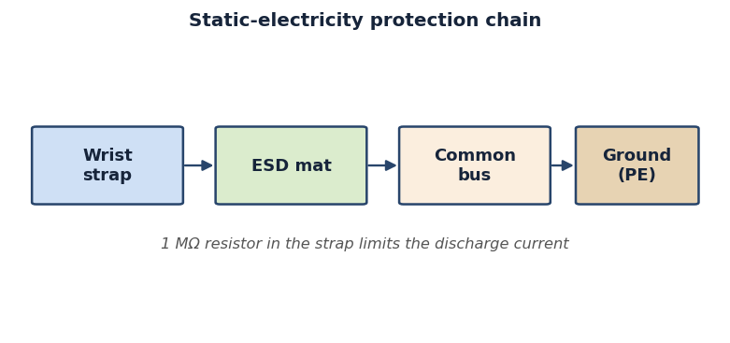
Figure 1. Static-electricity protection chain
CL: /1/.
Self-assessment questions:
1. What is electrostatic discharge, and why can it damage a board at a voltage the technician cannot feel?
2. Explain the difference between catastrophic and latent ESD failures.
3. Why does an anti-static wrist strap contain a one-megohm resistor, and how must it be connected?
4. Which items of personal protective equipment are needed when cleaning toner from a printer, and why?
5. List the main sanitary norms (area, microclimate, illumination) for a computer workstation.

Lecture No. 5
Topic: Personal Computer Architecture and Interaction of the Main Units
Plan:
1. The von Neumann model and the modern bus-based architecture of a PC.
2. Functional units: CPU, memory, chipset, input/output and storage subsystems.
3. Data, address and control paths and how the units exchange information.

A personal computer is a complex electronic system in which several functional units work together to fetch, process and store information. To judge whether such a system is operable at the circuit level, a technician must first understand how these units are organised and how they communicate. The conceptual foundation of almost every modern computer is the von Neumann model, which describes a machine built from a central processing unit, a single memory that holds both program instructions and data, and input/output facilities. Although today's machines add many refinements, the basic idea that the processor repeatedly fetches an instruction, decodes it, executes it and writes back a result remains the starting point for all hardware analysis.
The central processing unit, or CPU, is the active heart of the computer. Inside it are the arithmetic logic unit that performs calculations and logical operations, a set of registers that hold operands and intermediate results, and a control unit that sequences every step using the system clock. The CPU does not work in isolation: it constantly reads instructions and data from memory and writes results back. The speed and correctness of this dialogue depend on the electrical integrity of the connections between the processor and the rest of the board, which is exactly what the diagnostician later checks with instruments.
Main memory, implemented today as dynamic random access memory or RAM, stores the programs and data that the CPU is currently using. RAM is volatile, meaning that it loses its contents when power is removed, so its operation depends critically on stable supply voltages and correct timing signals. Alongside RAM the computer also contains non-volatile memory such as the flash chip that holds the BIOS or UEFI firmware. Understanding which memory is volatile and which is permanent helps the technician interpret symptoms: a machine that forgets settings has a different fault from one that cannot keep data while running.
Between the processor, the memory and the peripheral devices sits the chipset, a set of support chips that route signals and manage communication. In older designs the chipset was split into a northbridge, handling high-speed traffic to memory and graphics, and a southbridge, handling slower peripheral interfaces. In current designs much of the northbridge function has been integrated directly into the CPU package, leaving a single Platform Controller Hub for the remaining input/output. Whatever the exact division, the chipset is the traffic controller of the board, and faults in its supporting circuits can disable whole groups of devices.
The units of a PC do not exchange information over a single wire but over groups of conductors called buses. The data bus carries the actual information, the address bus carries the location in memory or the identity of a device, and the control bus carries timing and command signals such as read, write and interrupt requests. The width of the data and address buses, measured in bits, helps determine how much memory the machine can use and how much information it can move at once. When tracing a fault, recognising whether a problem lies on the data, address or control path narrows the search considerably.
Storage and input/output devices form the outer ring of the architecture. Solid-state and hard disk drives provide permanent, high-capacity storage, while devices such as the keyboard, mouse, display and network adapter let the machine interact with the world. These devices connect through standard interfaces and controllers that the chipset manages. Although they are slower than the CPU and memory, they are essential to a working system, and many apparent failures of the computer as a whole are in fact failures in the power or signalling that reaches one of these subsystems.
All of these units share a common dependence on a clean and correctly sequenced power supply and on a stable clock. When the machine is switched on, a defined start-up sequence brings up the voltages, releases the processor from reset and begins the power-on self-test. If any unit does not receive its supply or its clock at the right moment, the system will not start, even though each individual chip might be undamaged. This is why an operability check at the circuit level always considers the architecture as a cooperating whole rather than a collection of separate parts.
In practice, the technician keeps a mental map of the architecture and uses it to reason from a symptom back to a probable cause. A blank screen, repeated restarts or a refusal to power on each point to a particular region of the block diagram. By knowing which unit talks to which, over which bus and at which voltage, the specialist can plan a logical sequence of measurements instead of replacing parts at random. This architectural understanding is therefore the foundation on which every later, more detailed diagnostic skill in this learning outcome is built.
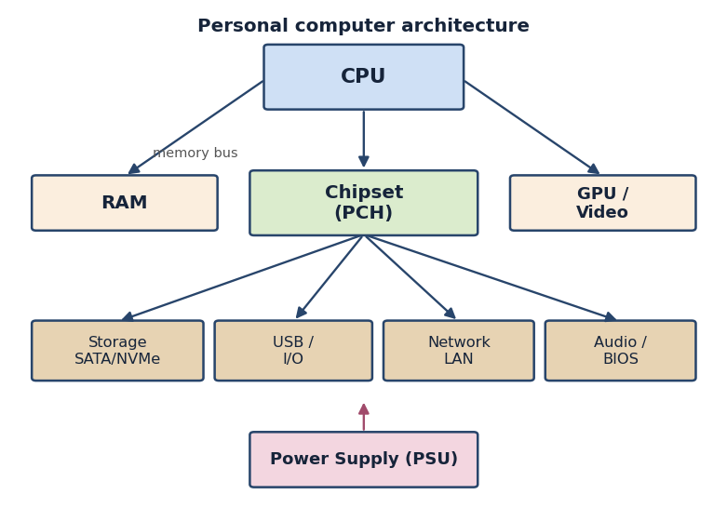
Figure 2. Personal computer architecture
CL: /1/, /2/.
Self-assessment questions:
1. Describe the von Neumann model and name its three basic parts.
2. What are the functions of the arithmetic logic unit, the registers and the control unit inside a CPU?
3. Explain the difference between volatile RAM and non-volatile firmware memory.
4. What roles do the northbridge, southbridge or modern Platform Controller Hub play?
5. Distinguish between the data bus, the address bus and the control bus.

Lecture No. 6
Topic: The Motherboard: Chipset, Buses, Connectors and Expansion Slots
Plan:
1. Layout of the motherboard and the function of its main components.
2. The chipset, system buses and expansion interfaces.
3. Power, signal and peripheral connectors and how they are identified.

The motherboard, or system board, is the large printed circuit board that physically and electrically ties together every part of a computer. It provides the sockets, slots and connectors into which the processor, memory and expansion cards are installed, and it carries the copper traces that form the buses linking them. Because every signal and almost every supply current passes through it, the motherboard is the central object of circuit-level diagnostics. A technician who can read the board's layout and identify its components is able to locate the right place to make a measurement when something goes wrong.
At the centre of the board is the processor socket, a precise mechanical and electrical interface that connects hundreds of CPU pins to the rest of the system. Close to it are the memory slots, usually DIMM connectors, into which RAM modules are inserted. Their proximity is deliberate: keeping the high-speed memory traces short preserves signal quality. Around these components are the voltage regulator circuits that convert the supply into the precise low voltages the processor and memory require. Recognising these regions is the first step in understanding what each part of the board does.
The chipset chips are mounted on the board as one or more relatively large integrated circuits, often hidden under a small heatsink. They act as the communication hub between the processor, the memory and the peripheral interfaces. The capabilities of the chipset determine how many devices the board can support, which interfaces are available and how fast they run. Faults in the chipset itself or in its surrounding support components frequently appear as the loss of a whole class of ports, such as all the USB connectors or all the SATA channels at once.
Buses on the motherboard are realised as bundles of parallel or serial copper traces. The high-speed serial PCI Express links connect the processor and chipset to graphics cards and fast expansion devices, while slower serial and legacy parallel buses serve other peripherals. Each bus has a defined electrical standard for voltage levels and timing, and the traces are routed with care to keep matched pairs equal in length. Understanding that a slot is the visible end of an internal bus helps the technician connect a malfunctioning card to the part of the board that serves it.
Expansion slots let the user add functionality to the computer. PCI Express slots of various sizes accept graphics cards, network adapters, storage controllers and other cards. Memory slots, although technically connectors rather than expansion slots, follow the same idea of a standard mechanical and electrical interface. Each slot carries supply voltages as well as data lines, so a card that fails to work may suffer either from a signalling problem or from a missing supply on the slot, and both possibilities must be considered during diagnosis.
A modern motherboard carries many connectors for power and signals. The main ATX power connector and the supplementary processor power connector bring in the voltages from the power supply unit. Headers connect the front-panel buttons and indicator lights, the fans, the storage drives and the USB ports of the case. Each connector has a defined pin assignment, and a service technician must be able to read the board's silk-screen markings and documentation to know which pin should carry which voltage or signal before placing a probe.
Beyond the large components, the board is covered with small passive parts: resistors, capacitors and inductors. The many capacitors near the processor and memory smooth the supply and store energy for sudden current demands, while inductors form part of the voltage regulator. These small components are common points of failure; a swollen or leaking capacitor or a cracked solder joint can stop the whole board from working. Learning to recognise them and to know where they belong in a circuit is essential for board-level fault finding.
Putting these elements together, the motherboard can be read as a map in which the processor and memory occupy the high-speed centre, the chipset coordinates communication, the expansion slots and connectors form the periphery, and the power and passive components keep everything supplied and stable. When a system shows a fault, the technician uses this map to decide whether the problem is likely in the supply, in the bus, in a connector or in a particular component. Form factors such as ATX, microATX and Mini-ITX standardise the size of the board and the position of its mounting holes and back-panel ports, so a technician who knows the standard can quickly orient themselves on any board. The skill of reading the motherboard therefore turns an intimidating board into an orderly, diagnosable structure on which methodical, instrument-based diagnosis becomes possible.
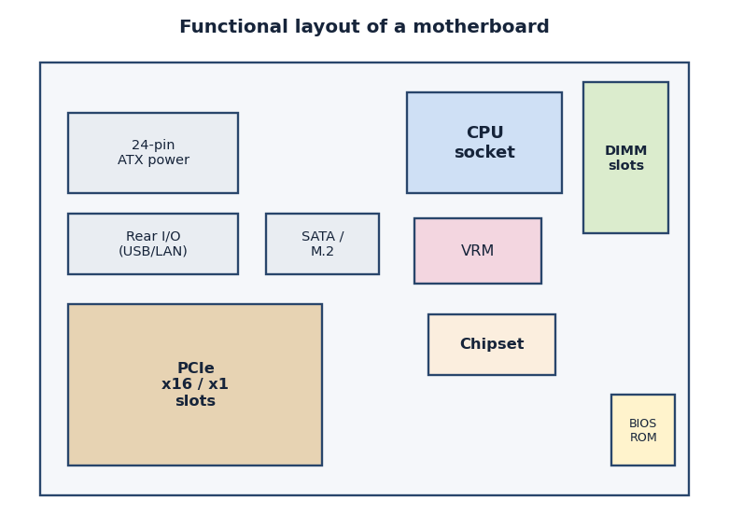
Figure 3. Functional layout of a motherboard
CL: /1/, /2/.
Self-assessment questions:
1. What is the purpose of the processor socket and why are the memory slots placed near it?
2. How does the chipset coordinate communication between the processor, memory and peripherals?
3. Explain the relationship between an expansion slot and the bus that serves it.
4. Name the main power connectors on an ATX motherboard and their function.
5. Why are capacitors near the CPU a common point of failure, and how are they recognised?

Lecture No. 7
Topic: Digital Circuitry: Logic Gates, Flip-Flops and Adders
Plan:
1. Binary signals, logic levels and the basic logic gates.
2. Combinational circuits such as adders built from gates.
3. Sequential elements: flip-flops, registers and memory of state.

Every digital computer ultimately works by representing information as two electrical states, conventionally called logic zero and logic one, which correspond to a low and a high voltage. A logic gate is the simplest building block that operates on these levels, taking one or more binary inputs and producing a binary output according to a fixed rule. Because the whole machine is assembled from gates, understanding their behaviour is the key to reading the schematics of any digital unit and to predicting what voltages should appear at a given point when the circuit is working correctly.
The fundamental gates are AND, OR and NOT. The AND gate outputs a one only when all of its inputs are one; the OR gate outputs a one when at least one input is one; and the NOT gate, or inverter, simply reverses its single input. From these three, the derived gates NAND, NOR and exclusive-OR are formed. The NAND and NOR gates are especially important because any logical function can be built entirely from copies of either one, which is why they are so common in real integrated circuits. The behaviour of each gate is summarised compactly in its truth table.
A truth table lists every possible combination of inputs and the output the gate produces for each. By writing out truth tables, a technician can verify whether a circuit is behaving as designed and can predict the expected output for a given set of inputs. This is directly useful in diagnosis: if the inputs to a gate are known and the output does not match the truth table, the gate or its connections are suspect. Truth tables thus turn the abstract rules of logic into a practical checklist for testing real hardware.
When gates are connected so that the output depends only on the present inputs, the result is a combinational circuit. A classic example is the half-adder, which adds two single bits and produces a sum and a carry using an exclusive-OR gate and an AND gate. Connecting half-adders and an extra gate produces a full-adder, which also accepts a carry from a previous stage. Chaining full-adders builds a circuit that can add multi-bit binary numbers, and this is precisely the kind of structure found inside the arithmetic logic unit of a processor.
Combinational circuits alone cannot remember anything, yet a computer must store the results of its operations. This is the role of sequential circuits, whose outputs depend not only on present inputs but also on past events. The basic sequential element is the flip-flop, a circuit that holds one bit of information until it is deliberately changed. A flip-flop is typically built from cross-connected gates that hold each other in a stable state, so it remains in its last condition until a new input or a clock pulse tells it to change.
Several types of flip-flop exist. The simple SR latch can be set or reset, the D flip-flop captures the value on its data input at the moment of a clock edge, and the JK and T types offer additional behaviour such as toggling. The clock signal is central to all of them: it synchronises when the stored value is allowed to change, so that all the flip-flops in a system update together in an orderly way. The presence and quality of the clock signal is therefore something a technician verifies when sequential logic misbehaves.
By grouping flip-flops together, designers build registers that store several bits at once, counters that advance through a sequence of values, and the cells of memory chips. The registers inside a CPU, the counters that generate addresses and the storage arrays of RAM are all ultimately collections of flip-flops driven by a common clock. Seeing memory and registers as ordered arrays of simple storage elements demystifies them and shows why a failure of the clock or supply can corrupt large amounts of stored information at once.
Real gates are not abstract symbols but physical electronic devices, today almost always built in CMOS technology from pairs of complementary transistors. This technology gives them well-defined high and low output voltages, very low power consumption when idle, and a noise margin that lets them reject small disturbances on their inputs. Understanding that each gate is a real circuit with finite switching speed and supply requirements explains why a digital unit can fail when its supply sags or when signal edges become slow and distorted, and it reminds the technician that even purely logical circuits depend on healthy analogue conditions.
For a service technician, the value of understanding gates, adders and flip-flops is that it makes the schematic of a digital unit readable rather than mysterious. Knowing the expected logic level at the input and output of a gate, or the timing relationship between a clock and a flip-flop, allows the use of an instrument such as a logic probe or an oscilloscope to confirm whether each stage is doing its job. This component-level reasoning is what separates a true diagnostician, who can localise a fault to a single device, from someone who can only swap whole boards in the hope of success.
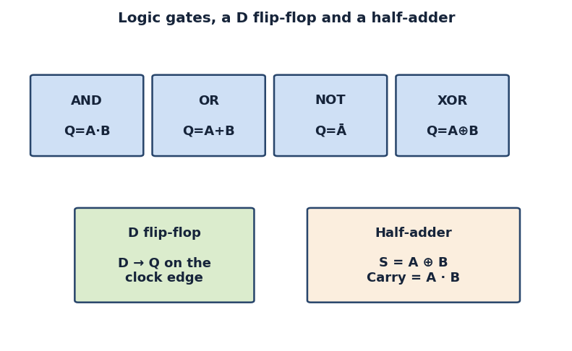
Figure 4. Logic gates, a D flip-flop and a half-adder
CL: /1/, /2/.
Self-assessment questions:
1. What voltage levels represent logic zero and logic one, and why are only two states used?
2. State the behaviour of the AND, OR and NOT gates and why NAND and NOR are called universal.
3. How does a full-adder differ from a half-adder, and how are multi-bit adders built?
4. Explain how a flip-flop stores one bit and the role of the clock signal.
5. How are registers, counters and memory cells related to flip-flops?

Lecture No. 8
Topic: The PC Power Subsystem: Power Supply, VRM Circuits and Voltage Generation
Plan:
1. The ATX power supply unit and the rails it provides.
2. Voltage regulator modules and point-of-load conversion on the board.
3. Start-up sequencing, protection and common power-related faults.

No computer can operate without a clean and correctly sequenced supply of electrical power, so the power subsystem is one of the first things a technician examines when assessing operability. The journey of power begins at the wall outlet, where alternating mains voltage enters the power supply unit. The unit's job is to convert this high alternating voltage into the several low, stable, direct voltages that the rest of the machine needs. Because so many faults trace back to power, a methodical understanding of how these voltages are produced and delivered is indispensable.
A standard ATX power supply is a switched-mode converter. It first rectifies and filters the mains to produce a high direct voltage, then switches that voltage at high frequency through a transformer to step it down efficiently, and finally rectifies and smooths the result into the output rails. The main rails are nominally twelve volts, five volts and three-point-three volts, together with a small standby five-volt rail that remains active even when the computer is switched off. Knowing the nominal value of each rail lets the technician judge whether a measured voltage is within tolerance.
The standby rail and the control signals deserve particular attention. The standby five-volt rail powers the circuits that wait for the user to press the power button. When the button is pressed, the motherboard asserts a signal, often called power-on, that tells the supply to start its main rails. In return the supply asserts a power-good signal once its outputs are stable, which releases the rest of the system from reset. A fault in this handshake can leave a perfectly healthy supply apparently dead, so the technician checks these signals as well as the raw voltages.
The voltages delivered by the power supply are not used directly by the processor and memory, because modern chips need much lower and more precisely controlled voltages that can change with load. This conversion is performed on the motherboard by voltage regulator modules, or VRMs. A VRM takes the twelve-volt rail and steps it down to roughly one volt for the processor core, supplying very large currents while keeping the voltage stable. These point-of-load regulators are built from switching transistors, inductors and capacitors arranged in phases to share the heavy current.
Each VRM phase is itself a small switching converter, and several phases operate in turn to deliver smooth power and to spread the heat. A dedicated controller chip monitors the output voltage and adjusts the switching to keep it on target as the processor's demand rises and falls. Because the VRM handles large currents, its transistors and inductors run warm and are common failure points. A technician who understands the phase structure can identify which component to inspect when the processor receives an incorrect or unstable supply.
Beyond the processor, similar regulator circuits generate the many other voltages a board needs, such as those for the memory, the chipset and the input/output interfaces. Each of these supplies must appear in the right order during start-up, because some chips can be damaged or simply refuse to operate if their voltages arrive out of sequence. The orderly bring-up of all these rails is part of the board's power management, and a missing or late rail is a frequent reason a system fails to start despite the main supply being present.
Power circuits also include protection features designed to prevent damage. Over-voltage, over-current and short-circuit protection will shut the supply down if something goes wrong, which is why a board with a short may cause the whole machine to switch off immediately after starting. Understanding that a protection shutdown is a symptom, not the root cause, guides the technician to look for the underlying short or overload rather than blaming the power supply itself. This distinction is central to correct fault localisation.
In practical diagnosis, the power subsystem is checked with a multimeter and sometimes an oscilloscope, measuring each rail against its nominal value and tolerance and confirming the presence of the control signals. A rail that is absent, too low, too high or excessively noisy points to a specific stage of the supply or regulator. An oscilloscope additionally reveals ripple and noise riding on a rail that a multimeter would average away, and excessive ripple is a classic sign of failing filter capacitors. Because almost every other unit depends on power, confirming that all voltages are correct, clean and stable is usually the first and most rewarding step in deciding whether a computer system is operable at the circuit level, and it often resolves the fault outright.
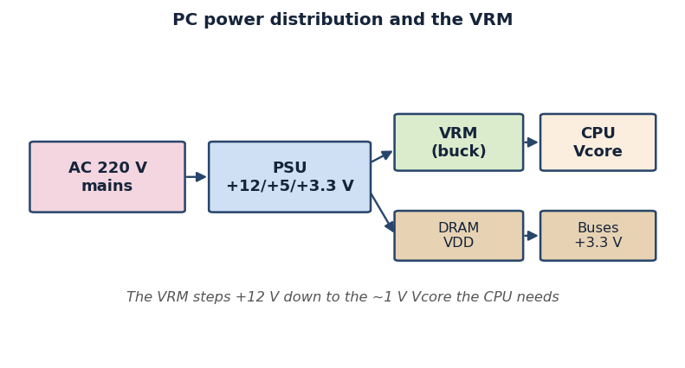
Figure 5. PC power distribution and the VRM
CL: /1/, /2/.
Self-assessment questions:
1. Describe the stages by which a switched-mode power supply converts mains voltage into low direct voltages.
2. What are the nominal output rails of an ATX supply and what is the role of the standby rail?
3. Explain the power-on and power-good signals and why they matter during start-up.
4. What is a VRM, why does it use multiple phases, and which components most often fail?
5. Why might a short circuit on the board cause the whole computer to switch off immediately?

Lecture No. 9
Topic: Memory and Clocking Subsystems: RAM, Frequency Generators, Data and Address Buses
Plan:
1. Organisation and operation of dynamic random access memory.
2. Clock generation, distribution and the role of frequency in timing.
3. Data and address buses and how memory accesses are carried out.

Main memory and the clock that times it form a closely linked subsystem whose correct operation is essential to a working computer. The memory holds the instructions and data the processor is using, while the clock provides the steady stream of pulses that synchronises every transfer between memory and the rest of the system. Because the two are so tightly coupled, a fault in the clocking circuit often appears as a memory problem, and understanding both together helps the technician interpret start-up failures and instability correctly.
Modern PCs use dynamic random access memory, in which each bit is stored as a charge on a tiny capacitor accessed through a transistor. This arrangement is dense and inexpensive but has a consequence: the stored charge leaks away and must be refreshed periodically by reading and rewriting every cell. The memory controller, now usually integrated into the processor, manages this refresh as well as the ordinary reading and writing. A technician should appreciate that memory operation depends on continuous refresh, stable supply and correct timing, so any of these can cause apparent memory faults.
Memory modules are organised into rows and columns of cells, and an access proceeds by selecting first a row and then a column. The controller issues a sequence of commands with precise timing, identified by parameters such as the row and column access delays. These timings must match the capability of the installed modules, information the system reads from a small configuration chip on each module at start-up. When timings are wrong, whether through a fault or misconfiguration, the memory may return corrupted data or fail to initialise at all.
The clock signal that drives the whole system originates from a stable reference, traditionally a quartz crystal oscillator whose mechanical resonance produces a very accurate frequency. From this reference, clock generator chips and the phase-locked loops inside the processor and chipset multiply and divide the frequency to produce the many different clock rates the various subsystems need. The accuracy and stability of this generated clock directly affect whether high-speed memory and bus transfers succeed, so the clock circuits are a natural object of inspection during diagnosis.
Clock signals must be distributed across the board to every device that needs them, and this distribution is itself a careful piece of engineering. The traces carrying the clock are routed to keep their lengths matched so that the pulses arrive at the right moments, and the signals are buffered to drive several destinations without distortion. A missing, weak or jittery clock can stop a subsystem from working even when its power is perfectly good, which is why an oscilloscope is often used to confirm that the expected clock waveform is present and clean.
Memory exchanges information with the processor over the data bus, while the location to be accessed is specified on the address bus. The width of the data bus determines how many bits move in a single transfer, and the width of the address bus determines how much memory can be addressed. Control signals accompanying these buses indicate whether the operation is a read or a write and when the data on the bus is valid. Recognising these three groups of signals lets the technician reason about exactly which part of a memory access might be failing.
A complete memory operation therefore combines several actions: the controller places an address on the address bus, asserts the appropriate control signals, and either drives data onto the data bus for a write or reads data from it for a read, all paced by the system clock. If any of these elements is disturbed, by a broken trace, a faulty module or an absent clock, the transfer fails. Understanding the sequence allows a logical search for the fault rather than guesswork, narrowing the problem to the address path, the data path, the control signals or the clock.
For practical operability checks, the technician confirms that the memory receives its correct supply voltages, that the clock waveform is present and stable, and that the module is recognised and configured at start-up. A frequent practical step is to reseat a module or test with a known-good one, because oxidised or poorly inserted contacts are a common cause of memory faults that no amount of probing of the chips themselves will explain. Tools range from simple voltage measurement to oscilloscope observation of clock and bus signals, and the symptoms, such as failure to start, repeated memory errors or instability only under load, are interpreted in the light of how the subsystem works. Mastery of the memory and clocking subsystem thus rounds out the technician's ability to assess a board at the circuit level.
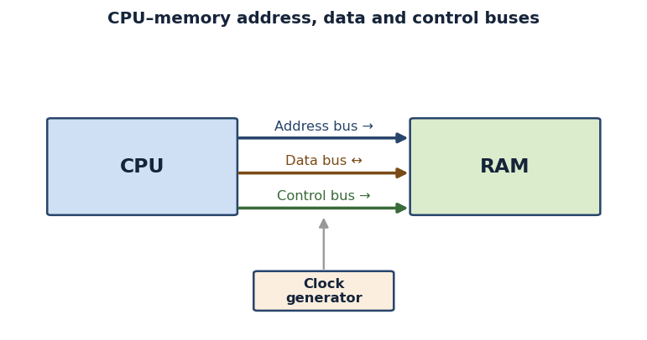
Figure 6. CPU–memory address, data and control buses
CL: /1/, /2/.
Self-assessment questions:
1. Why must dynamic RAM be refreshed, and which component manages this process?
2. Describe how a memory access selects a row and then a column within a module.
3. What is the role of a crystal oscillator and a phase-locked loop in clock generation?
4. Why must clock traces be length-matched and buffered when distributed across the board?
5. Explain the parts played by the data bus, the address bus and the control signals in a memory operation.

Lecture No. 10
Topic: Test and Measurement Instruments and Methods for Checking Signals on a Board
Plan:
1. Common diagnostic instruments and what each one measures.
2. Using the multimeter and the oscilloscope safely and correctly.
3. Choosing the right instrument and method for a given signal.

Deciding whether a computer is operable at the circuit level requires more than knowledge of how the hardware works; it requires the ability to measure real electrical quantities and compare them with expected values. A range of test and measurement instruments makes this possible, each suited to a particular kind of signal. Selecting the correct instrument and using it properly is a core professional skill, because a measurement made with the wrong tool, or made carelessly, can give misleading results or even damage the board under test.
The most frequently used instrument is the digital multimeter, a versatile device that measures voltage, current and resistance and usually offers a continuity test. For computer servicing it is used above all to check the direct-current voltages of the power rails against their nominal values, to test for continuity of traces and connectors, and to detect short circuits by measuring very low resistance. Its great advantages are simplicity, safety and low cost, which make it the everyday companion of the service technician for steady, slowly changing quantities.
The multimeter does, however, have limits: it reports only steady or average values and cannot show how a signal changes over time. For signals that vary rapidly, such as clocks, data lines and the switching waveforms inside a power regulator, the oscilloscope is the instrument of choice. An oscilloscope displays voltage as a function of time on a screen, so the technician can see the shape, amplitude, frequency and timing of a waveform. This makes it possible to confirm that a clock is present and clean or that a bus signal has the correct levels and edges.
Other instruments complement these two. A logic probe gives a quick indication of whether a point in a digital circuit is high, low or pulsing, which is useful for fast checks without setting up an oscilloscope. A specialised power supply tester can load and check the rails of an ATX supply, and a POST diagnostic card reports the progress of the start-up self-test as numeric codes. Each of these tools answers a specific question, and the skilled technician keeps a clear idea of which instrument is appropriate for which symptom.
Using a multimeter correctly begins with selecting the right function and range and connecting the leads properly: in series for current and in parallel for voltage. The black lead is placed on a known ground point and the red lead on the point of interest, and the reading is compared with the expected value and its tolerance. Continuity and resistance measurements must be made with the board unpowered, since applying the meter's test current to a live circuit gives false readings and may cause damage. Careful, methodical use yields trustworthy numbers.
Using an oscilloscope requires attention to the probe and its ground connection. The probe's ground clip must be attached to a proper ground close to the measurement point so that the displayed waveform is not distorted by noise. The vertical and horizontal scales are adjusted so the waveform fills the screen at a readable size, and the trigger is set so the trace is stable. Only then can the technician reliably read amplitude, period and shape and judge whether the signal matches what the circuit should produce.
Safety underlies every measurement. Inside a power supply, dangerous mains-derived voltages and charged capacitors can be present even after the unit is switched off, so the technician must respect these hazards and avoid probing live high-voltage sections without proper training and equipment. On the low-voltage side of the board, the main risk is to the hardware rather than the person, but careless probing that bridges two pins can create a short and cause damage. Respect for both kinds of risk is part of professional conduct.
A measurement is only meaningful when it is compared against a known reference. The technician therefore works with the board's documentation, the nominal values printed in service tables and, where possible, a known-good board of the same type for comparison. A reading that looks unusual in isolation may be perfectly normal once the expected value and its tolerance are known, while a small deviation may be significant on a rail that should be tightly regulated. Recording measurements in an orderly way also helps track intermittent faults that appear only under particular conditions.
Choosing the right instrument and method is ultimately guided by the nature of the signal and the question being asked. Steady supply voltages and continuity are tasks for the multimeter; clocks, data edges and switching waveforms call for the oscilloscope; a quick high-low check suits a logic probe; and the overall progress of start-up is read from a POST card. By matching the tool to the signal, comparing every reading with its expected value, and applying each instrument carefully and safely, the technician obtains the reliable measurements on which every circuit-level judgement of operability depends.
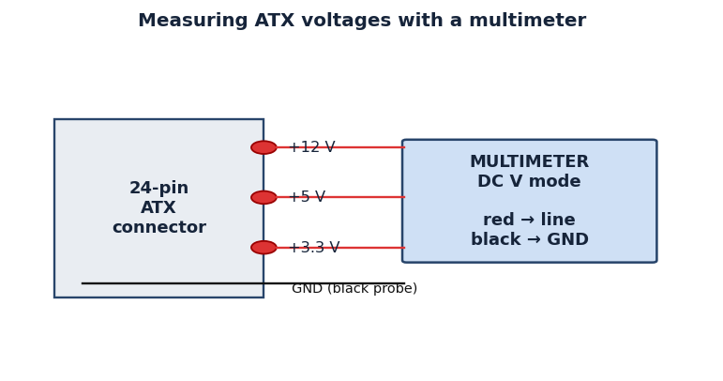
Figure 7. Measuring ATX voltages with a multimeter
CL: /1/, /2/.
Self-assessment questions:
1. What quantities does a digital multimeter measure and for which tasks is it best suited?
2. Why is an oscilloscope needed for clock and data signals that a multimeter cannot show?
3. How should multimeter leads be connected for voltage, for current and for continuity tests?
4. Why must the oscilloscope probe ground be connected close to the measurement point?
5. What safety hazards exist inside a power supply and how should the technician respond to them?

Lecture No. 11
Topic: Reading Schematic and Block Diagrams to Assess Unit Operability
Plan:
1. The purpose and types of technical diagrams: block and schematic.
2. Common symbols, reference designators and how to follow a circuit.
3. Using diagrams to plan a logical diagnostic procedure.

Technical diagrams are the language in which electronic equipment is described, and the ability to read them is what allows a technician to move beyond replacing whole assemblies and instead reason about individual circuits. Two kinds of diagram are especially important. A block diagram shows the major functional units of a system and the connections between them at a high level, while a schematic diagram shows the individual components and every electrical connection in detail. Together they let the specialist see both the overall structure and the fine wiring of the hardware.
A block diagram is the natural starting point because it presents the architecture at a glance. Each block represents a functional unit, such as the processor, the memory, a regulator or an interface, and the lines between blocks show how signals and power flow. By studying a block diagram, the technician forms a mental model of how a fault in one block might affect another, and can decide which region of the system to examine first. It is, in effect, a road map that turns a complex board into an understandable set of cooperating parts.
When more detail is needed, the schematic diagram takes over. Here every resistor, capacitor, transistor and integrated circuit is drawn with a standard symbol, and every connection is shown as a line. Standard symbols mean that a schematic drawn by one engineer can be read by another anywhere, because the meaning of each symbol is agreed by convention. Learning the common symbols for power, ground, passive components and active devices is the basic vocabulary that makes a schematic readable rather than a confusing tangle of lines.
Components on a schematic are labelled with reference designators, short codes such as R for a resistor, C for a capacitor, Q for a transistor and U for an integrated circuit, each followed by a number. These same designators are printed on the board itself next to the corresponding part, so the technician can move confidently between the paper diagram and the physical hardware. Matching a designator on the schematic to the part on the board is the practical link that lets a measurement planned on paper be carried out on the real circuit.
Reading a schematic is a matter of following signals from one point to another. Power and ground are usually shown with dedicated symbols rather than long wires, so the reader learns to recognise where supply enters a stage and where it returns. Following a signal from an input, through the components that process it, to an output reveals what each part of the circuit does. Net labels and connectors indicate where a signal continues on another sheet, so even a large multi-page schematic can be traced systematically without losing the thread.
The real value of these diagrams appears when they are used to assess operability. Knowing the expected voltage at a node, or the expected waveform on a line, the technician can predict what a healthy circuit should show and then measure to confirm it. A reading that disagrees with the diagram points directly to the faulty stage. In this way the schematic turns an abstract judgement of whether a unit works into a concrete sequence of comparisons between expected and measured values, which is the essence of circuit-level diagnosis.
Diagrams also make it possible to plan a logical and efficient diagnostic procedure rather than testing at random. Starting from the block diagram, the technician decides which functional area is most likely responsible for a symptom, then descends into the schematic of that area to identify specific points to measure. Working methodically from the supply outward, or from a known-good signal toward the fault, keeps the search orderly. This disciplined approach saves time and avoids the unnecessary replacement of healthy parts.
Modern boards are rarely documented by a single sheet, and the technician often works with a set of related drawings: a top-level block diagram, detailed schematics for each functional area, and a board layout or assembly drawing that shows where each part physically sits. Cross-referencing these is a skill in itself, because a node identified on the schematic must be found on the layout before it can be probed. Service manuals and component placement diagrams therefore become essential companions to the schematic, and learning to navigate between them smoothly is part of becoming an efficient diagnostician.
For a graduate of this module, fluency in reading block and schematic diagrams ties together everything learned about architecture, components, power and instruments. The diagram tells the technician what should be present, the knowledge of the hardware explains why, and the measuring instruments confirm whether it actually is. The capacity to combine these into a clear, evidence-based judgement of whether each unit is operable is the practical goal of the whole learning outcome, and it rests squarely on the skill of reading technical diagrams accurately and confidently.
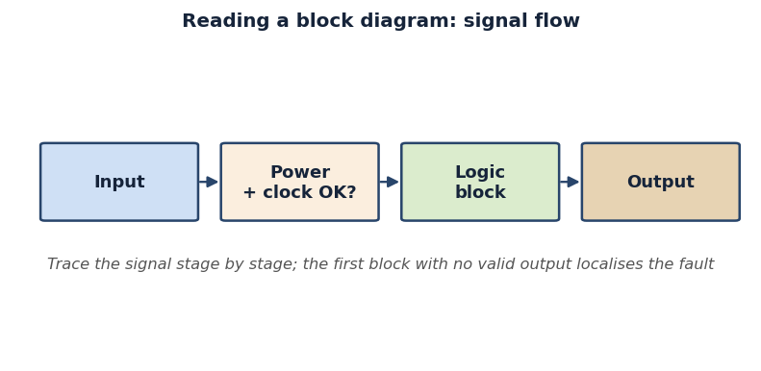
Figure 8. Reading a block diagram: signal flow
CL: /1/, /2/.
Self-assessment questions:
1. What is the difference between a block diagram and a schematic diagram, and when is each used?
2. Why are standard component symbols important for reading schematics?
3. What are reference designators and how do they link the schematic to the physical board?
4. How does following a signal through a schematic reveal the function of a circuit stage?
5. Describe how block and schematic diagrams are used together to plan a logical diagnostic procedure.

Lecture No. 12
Topic: Rules of Computer Operation and Operating Modes of Computing Equipment
Plan:
1. Principles of correct computer operation and the operating environment
2. Power-up, shutdown and power management modes (sleep, hibernate, restart)
3. Operating documentation, regulations and the operator's responsibilities

Correct operation of computing equipment is the foundation on which reliable, long-lasting and safe service rests. A computer is a complex electronic system whose components are sensitive to environmental conditions, electrical quality and the discipline of the people who use it. The term "operation" covers everything that happens between the moment a machine is installed and the moment it is decommissioned: powering it on and off, loading the operating system, running applications, connecting and disconnecting devices, and observing the rules that keep the hardware within its rated limits. An operator who understands these rules prevents the majority of failures before they occur, because most premature breakdowns are caused not by manufacturing defects but by careless handling, unstable power and unsuitable environmental conditions.
The operating environment must be controlled within the limits stated by the manufacturer. Ambient temperature for a typical desktop or server is usually kept between eighteen and twenty-four degrees Celsius, with relative humidity around forty to sixty percent. Excessive heat accelerates the ageing of semiconductors and electrolytic capacitors, while very low humidity increases the risk of static-electricity discharge and very high humidity encourages condensation and corrosion. Dust is a constant enemy: it clogs fans and heatsinks, forms an insulating blanket on circuit boards and reduces airflow, so machines should stand in clean, well-ventilated spaces with their ventilation openings unobstructed by walls, paper or other equipment. Direct sunlight, vibration and proximity to strong electromagnetic sources should all be avoided.
Electrical supply quality is equally important. Computers should be connected through properly earthed sockets, and in critical installations through an uninterruptible power supply (UPS) and a surge protector. The UPS performs two essential functions: it absorbs short voltage sags and spikes, and it provides enough battery time for a controlled shutdown when mains power fails. A sudden loss of power during a write operation can corrupt the file system or damage a drive, so the operator must never rely on simply pulling the plug. Equipment should be switched on and off in the correct sequence — peripherals and monitors first when starting in some installations, the system unit last when shutting down — and the load on a single circuit must not exceed its rating.
The power-up sequence itself follows a defined order. When the power button is pressed, the power supply stabilises its output voltages and asserts the Power-Good signal, after which the processor begins executing firmware code from the BIOS or UEFI. The firmware runs the Power-On Self-Test (POST), which checks the presence and basic health of the processor, memory, and essential controllers, and then hands control to the boot loader of the operating system. The operator should allow this sequence to complete fully and should never force a power-off during boot unless the machine is clearly frozen. A normal, graceful shutdown allows the operating system to flush caches to disk, close open files and park drive heads, which protects both data and hardware.
Modern systems offer several power-management modes that balance availability against energy consumption and component wear. Sleep (standby) keeps the contents of memory powered while shutting down most other subsystems, allowing the machine to resume in seconds; hibernate writes the entire memory image to disk and powers the system off completely, preserving the session through a total loss of power; and a full shutdown ends all activity. Restart performs a controlled shutdown followed immediately by a fresh boot, which is the recommended way to apply many updates and to clear an unstable software state. Understanding when to use each mode lets the operator reduce electricity use and thermal stress without sacrificing the integrity of running work.
Operation is governed by documentation. Every organisation that maintains a fleet of computers should keep operating instructions, manufacturer manuals, warranty conditions and internal regulations describing permitted and forbidden actions. These documents specify, for example, who may open a system unit, how software may be installed, and what to do when a fault is detected. The operator is expected to follow them precisely, to record significant events such as malfunctions, restarts and maintenance in an operations log, and to refrain from any modification that would void the warranty or breach safety rules. Disciplined record-keeping turns isolated incidents into a history that reveals recurring problems and supports planned maintenance.
The operator's responsibilities therefore extend well beyond simply turning machines on. They include verifying that the workplace meets environmental and electrical requirements, observing the correct start-up and shutdown procedures, monitoring the behaviour of the equipment during use, and reacting calmly and correctly to abnormal symptoms such as unusual noise, overheating, error messages or unexpected restarts. The operator must also protect data through orderly shutdowns and avoid actions that endanger people or equipment, such as connecting devices to a live high-current circuit or blocking ventilation. In effect, the operator is the first line of defence for the whole computing installation, and the quality of their daily routine directly determines how reliably the equipment serves the enterprise.
To summarise, the rules of computer operation form a coherent system that links the physical environment, the electrical supply, the start-up and shutdown sequences, the available power modes and the surrounding documentation into a single discipline. When these rules are followed, machines run cooler, last longer, lose less data and require fewer emergency repairs. When they are ignored, even high-quality hardware fails prematurely. For the future specialist in maintenance of computing equipment, mastering correct operation is not a formality but the practical basis of every other skill in the module, because diagnosis, maintenance and repair all begin from an installation that has been operated correctly.
Example (commands / script):
:: Windows — list and switch power schemes
powercfg /list
powercfg /setactive SCHEME_BALANCED
powercfg /change monitor-timeout-ac 15
powercfg /energy :: energy-efficiency report

# Linux — check and set the CPU frequency governor
cat /sys/devices/system/cpu/cpu0/cpufreq/scaling_governor
sudo cpupower frequency-set -g powersave

CL: /1/, /3/.
Self-assessment questions:
1. What environmental parameters (temperature, humidity, dust) must be maintained for the reliable operation of computing equipment, and why does each matter?
2. Why should a computer be connected through a UPS and a surge protector, and what risks arise from a sudden loss of mains power?
3. Describe the normal power-up sequence from pressing the power button to loading the operating system.
4. Compare the sleep, hibernate, shutdown and restart modes and explain when each should be used.
5. What are the main responsibilities of an operator with respect to operating documentation and the operations log?

Lecture No. 13
Topic: Peripheral Devices: Classification, Interfaces and Connection Principles
Plan:
1. Classification of peripheral devices: input, output and combined devices
2. Common interfaces and connectors (USB, HDMI/DisplayPort, network, legacy ports)
3. Principles of connection, driver installation and safe disconnection

Peripheral devices are the hardware components that connect to the central system unit and extend the capabilities of the computer beyond pure computation. While the processor, memory and storage form the core of the machine, it is the peripherals that allow a human being to enter information, to receive results in a usable form, and to exchange data with other systems. A specialist responsible for the operation and control of computers must understand how peripherals are classified, through which interfaces they connect, and what rules govern their safe and correct attachment, because a large share of everyday user problems and service calls relate not to the system unit itself but to the printers, monitors, scanners and other devices around it.
Peripheral devices are traditionally classified by the direction in which information flows. Input devices bring data into the computer: the keyboard and mouse are the most familiar examples, joined by scanners, graphics tablets, webcams, microphones, barcode readers and game controllers. Output devices present the results of processing to the outside world: monitors display visual information, printers and plotters produce hard copies, and loudspeakers and headphones deliver sound. A third group is best described as combined or storage and communication devices, which both send and receive data; these include touchscreens, multifunction printers, external drives, network adapters and modems. Understanding this classification helps the operator predict how a device behaves.
Printers, scanners and monitors deserve particular attention because they are the most common peripherals in any office. Printers may be inkjet, which form an image by spraying tiny droplets of liquid ink, or laser, which use a charged drum and toner powder fused by heat; each technology has its own consumables and maintenance needs. Scanners convert a physical document or image into a digital file using a moving optical sensor, and are frequently combined with a printer in a single multifunction unit. Monitors are output devices that render the video signal produced by the graphics adapter and are characterised by resolution, refresh rate and colour reproduction. Knowing the operating principle of each class lets the operator set it up correctly and recognise typical faults.
Devices communicate with the computer through interfaces, which define both the physical connector and the electrical and logical rules of the exchange. The Universal Serial Bus (USB) has become the dominant general-purpose interface; it supports a wide range of devices, supplies power as well as data, and allows hot-plugging, meaning devices can be connected and disconnected while the system is running. Video is carried by digital interfaces such as HDMI and DisplayPort, and in older equipment by analogue VGA or digital DVI. Networking uses the Ethernet RJ-45 connector or wireless adapters. Audio uses standard jacks, and legacy systems may still expose PS/2, serial (COM) and parallel (LPT) ports. Each interface has its own bandwidth, cable length limits and connector shape, and matching a device to the correct port is the first step of any successful connection.
The principles of connection follow from the nature of the interface. Hot-pluggable interfaces such as USB and most network connections allow a device to be attached while the computer is powered on, after which the operating system detects it and prepares it for use. Interfaces that are not hot-pluggable, or internal expansion cards, generally require the machine to be switched off before the device is connected, to avoid electrical damage. In every case the operator must use the correct cable, insert connectors in the proper orientation without forcing them, and ensure that the device receives adequate power, either from the bus or from its own supply. A device drawing more current than a port can provide will behave unreliably or fail to start.
Once the physical connection is made, the operating system must be able to control the device, and this is the role of the driver. A driver is a software module that translates the general requests of the operating system into the specific commands understood by a particular device. Many common peripherals are supported by drivers built into the operating system and are configured automatically through plug-and-play; more specialised devices require a driver supplied by the manufacturer to be installed before all their functions become available. The operator should obtain drivers from a trustworthy source, install the version that matches the device model and the operating system, and keep them reasonably up to date, since outdated or incorrect drivers are a frequent cause of malfunction and instability.
Safe disconnection is as important as correct connection, especially for storage and communication devices. Removing a USB flash drive or external disk while data is still being written can corrupt the file system or destroy files, so the operating system provides a "safely remove hardware" function that flushes outstanding data and signals when the device may be detached. For non-storage devices such as a mouse or keyboard, simple unplugging is acceptable, but the operator should still avoid disconnecting devices during critical operations. Cables should be removed by gripping the connector rather than pulling the cord, to prevent mechanical damage to both the cable and the port.
In summary, peripheral devices transform a bare computing core into a complete, usable workstation, and their reliable operation depends on a clear understanding of three things: how devices are classified by the direction of information flow, which interface and connector each device uses, and what rules govern its connection, driver installation and disconnection. An operator who masters these fundamentals can configure new equipment quickly, diagnose connection and driver problems with confidence, and protect both the data and the hardware of the installation. This knowledge forms the practical bridge between the theoretical architecture of the computer and the hands-on tasks of setting up and supporting real peripheral equipment.
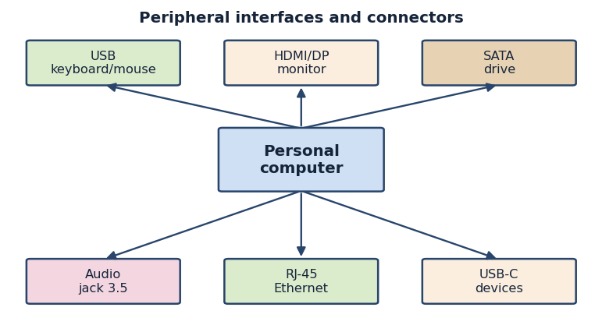
Figure 9. Peripheral interfaces and connectors
CL: /1/, /3/.
Self-assessment questions:
1. How are peripheral devices classified by the direction of information flow, and give two examples of each group.
2. Describe the operating principles of inkjet and laser printers and explain how a scanner converts a document into a digital file.
3. What is the difference between hot-pluggable and non-hot-pluggable interfaces, and how does this affect the connection procedure?
4. What is the function of a device driver, and why must the correct driver version be installed for a peripheral?
5. Why is the "safely remove hardware" function important for storage devices, and how should cables be disconnected correctly?

Lecture No. 14
Topic: Monitoring the State of Equipment: Temperature, Load and Event Logs
Plan:
1. Goals of hardware monitoring and the parameters being observed
2. Tools and sensors: temperature, performance counters, S.M.A.R.T. and event logs
3. Interpreting indicators and reacting to abnormal conditions

Monitoring the state of computing equipment is the practice of continuously observing the physical and logical parameters of a system in order to confirm that it is operating within safe limits and to detect the early signs of trouble. A computer rarely fails without warning; before a catastrophic breakdown there are usually measurable symptoms such as rising temperatures, abnormal load, a failing drive reporting errors, or repeated entries in the system logs. The operator who watches these indicators can intervene before a minor issue becomes a serious failure, schedule maintenance at a convenient time rather than reacting to an emergency, and keep the installation running smoothly. Monitoring therefore turns operation from a passive activity into an active, preventive discipline.
The first group of parameters concerns temperature and cooling. Processors, graphics adapters, chipsets and drives all generate heat, and every component has a maximum safe operating temperature above which it throttles its performance to protect itself or, in extreme cases, shuts down. Sensors built into modern hardware report these temperatures continuously, and the operator can read them through the firmware setup screen or through monitoring utilities running in the operating system. Closely related is the behaviour of the cooling system: fan speeds, measured in revolutions per minute, indicate whether the cooling response is matching the heat load. A processor that runs unusually hot, or a fan that has stopped, is a clear signal that dust, a failed bearing or dried thermal paste needs attention.
The second group of parameters concerns load and performance. The operating system exposes performance counters that report the utilisation of the processor, the amount of memory in use, the activity of the disks and the throughput of the network. Sustained high processor or memory utilisation may indicate that the machine is underpowered for its task, that a process has malfunctioned, or that malicious software is consuming resources. High disk activity with poor responsiveness can point to a failing drive or insufficient memory forcing the system to swap data to disk. By observing these counters over time, the operator builds a picture of what is normal for a given machine, which makes any deviation easy to spot and explain.
Storage devices provide their own form of self-monitoring through a technology known as S.M.A.R.T. (Self-Monitoring, Analysis and Reporting Technology). Both traditional hard drives and solid-state drives continuously record attributes such as the number of reallocated sectors, read and write error rates, power-on hours and, for solid-state media, the amount of wear consumed. A monitoring utility can read these attributes and warn the operator when a drive begins to deteriorate, often days or weeks before it fails completely. Because the loss of a storage device can mean the loss of valuable data, S.M.A.R.T. monitoring is one of the most valuable preventive tools available, giving the operator time to back up data and replace the drive in a controlled manner.
Event logs are the system's written record of significant occurrences. The operating system maintains logs that record errors, warnings and informational events generated by the kernel, drivers, services and applications. When a device driver fails to load, when a service crashes, when a disk reports an error or when the system restarts unexpectedly, an entry appears in the log with a timestamp, a source and a description. By reviewing these logs the operator can reconstruct the sequence of events leading to a problem, distinguish a one-off glitch from a recurring fault, and identify the specific component or software responsible. Skilled log analysis is one of the most powerful diagnostic techniques available.
A wide range of tools supports monitoring in practice. The firmware setup screen shows basic temperatures and voltages even before the operating system loads. Within the operating system, built-in utilities such as the task manager and the performance and event-log viewers provide a first level of insight, while specialised third-party utilities offer more detailed sensor readings, historical graphs and configurable alerts. In larger installations, monitoring software collects data from many machines into a central console and can send automatic notifications when a threshold is crossed. Whatever the scale, the principle is the same: gather the relevant indicators, compare them against known-good baselines, and raise an alarm when a value moves outside its acceptable range.
Interpreting the collected data is the skill that gives monitoring its value. A single high reading is not always a cause for alarm; a processor may briefly reach a high temperature under heavy load and then cool down normally, and short bursts of full utilisation are expected during demanding tasks. What matters is the pattern over time and the comparison against the established baseline for that machine. A temperature that stays high at idle, a fan speed that never rises despite heat, a steadily growing count of reallocated sectors, or a log that fills repeatedly with the same error are the patterns that demand action. The operator must learn to separate normal fluctuation from genuine warning signs, and to react proportionately rather than over-reacting to every transient.
When an abnormal condition is confirmed, the operator follows a measured response: record the observation in the operations log, investigate the likely cause using the available tools, take protective action such as backing up data or reducing load, and, where necessary, schedule maintenance or replacement. The goal is always to act before a small problem becomes a large one. In this way, systematic monitoring of temperature, load, drive health and event logs allows the operator to control the working of computers and peripheral devices proactively, to extend the service life of the equipment, and to maintain the reliability that the enterprise depends upon, fulfilling the core purpose of the operation and control function described in this learning outcome.
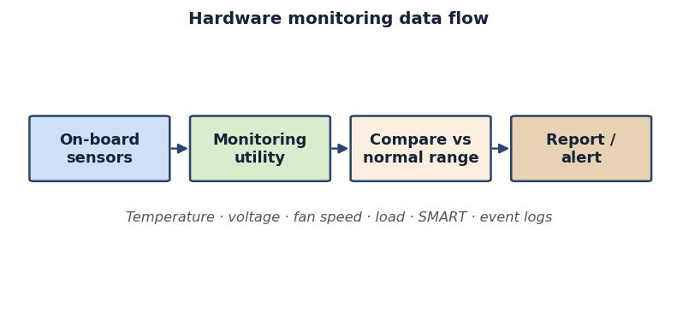
Figure 10. Hardware monitoring data flow
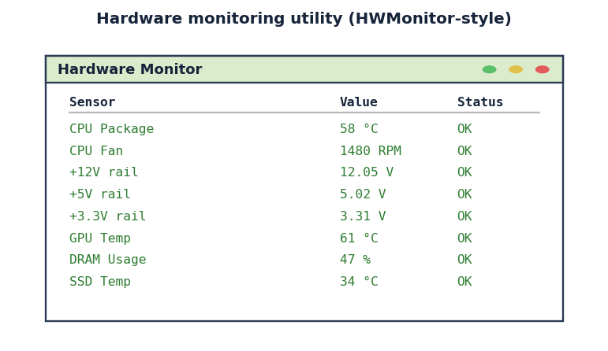
Figure 11. Hardware monitoring utility interface
Example (commands / script):
# Linux — temperatures, load and disk health
sensors # CPU/board temperatures
uptime # load average
smartctl -H /dev/sda # quick SMART health check

# Python (psutil) — log key sensors to a report
import psutil
print('CPU load %:', psutil.cpu_percent(interval=1))
for name, items in psutil.sensors_temperatures().items():
for s in items:
print(name, s.label, s.current, 'C')

CL: /1/, /3/.
Self-assessment questions:
1. What are the main goals of monitoring the state of computing equipment, and why is monitoring a preventive rather than a passive activity?
2. Which temperature and cooling parameters should be observed, and what do an unusually high temperature or a stopped fan indicate?
3. What is S.M.A.R.T. technology, and how does it help prevent the loss of data from a failing drive?
4. How can event logs be used to diagnose a recurring fault, and what information does a typical log entry contain?
5. Why is it important to compare current readings against a baseline, and how should an operator respond when an abnormal condition is confirmed?

Lecture No. 15
Topic: Preventive Maintenance and Extending the Service Life of Equipment
Plan:
1. The purpose and types of preventive maintenance
2. Hardware maintenance procedures: cleaning, cooling, connections and consumables
3. Software maintenance and planning a maintenance schedule

Preventive maintenance is the planned, regular care of computing equipment carried out to keep it in good working order and to prevent failures before they happen, in contrast to corrective maintenance, which only repairs equipment after it has already broken down. The economic and practical advantages of prevention are well established: a small amount of routine attention costs far less than an emergency repair, avoids the disruption of unexpected downtime, protects valuable data, and significantly extends the working life of the hardware. For the specialist responsible for the operation and control of computers and peripheral devices, the ability to plan and perform preventive maintenance is one of the most important professional skills, because it directly determines how reliably and economically an installation serves its purpose over many years.
Preventive maintenance is usually divided into two complementary domains: hardware maintenance, which deals with the physical condition of the equipment, and software maintenance, which deals with the operating system and applications. It is also classified by how it is triggered. Time-based or scheduled maintenance is performed at fixed intervals, such as a monthly cleaning or a quarterly inspection, regardless of the apparent condition of the machine. Condition-based maintenance is triggered by the monitoring indicators discussed earlier, so that action is taken when temperatures rise, drive health declines or logs reveal recurring errors. A mature maintenance programme combines both approaches, using a regular baseline schedule and adjusting it in response to what monitoring reveals.
The most fundamental hardware maintenance task is cleaning, because dust is the single greatest enemy of reliable operation. Over time dust accumulates on fan blades, clogs the fins of heatsinks and forms an insulating layer on circuit boards, reducing airflow and trapping heat. The operator removes this dust at regular intervals, typically with compressed air and soft brushes, taking care to hold fans still so they are not spun beyond their rated speed and to avoid generating static discharge. A clean machine runs cooler, and because heat is the primary driver of component ageing, effective cleaning is one of the most powerful ways to extend service life. Cleaning also extends to peripherals, including printer mechanisms, scanner glass and the surfaces of monitors and keyboards.
Maintaining the cooling system goes beyond removing dust. The thermal interface material between a processor and its heatsink dries out over years of use and loses its ability to conduct heat, so on older machines it may need to be cleaned off and renewed. Fans wear out as their bearings degrade, becoming noisy and slow, and a worn fan should be replaced before it fails entirely. The operator should also verify that airflow paths inside the case are unobstructed and that the machine has adequate ventilation around it. Alongside cooling, all physical connections deserve periodic attention: cables and connectors can loosen through vibration or thermal cycling, so reseating memory modules, expansion cards and cable connectors during a service can resolve intermittent faults before they become persistent.
Consumables and wear parts form another important part of physical maintenance, particularly for peripherals. Printers consume ink, toner and, in laser models, drum units and fusers, all of which must be replaced on a planned basis to maintain print quality and avoid mechanical damage. Batteries also count as wear parts: the small cell on the motherboard that preserves the firmware clock and settings eventually depletes, and the battery in an uninterruptible power supply loses capacity over a few years and must be tested and replaced so that it can still protect the system during a power failure. Anticipating the replacement of wear parts, rather than waiting for them to fail, keeps the installation dependable.
Software maintenance is the second pillar of prevention and is just as important as physical care. Operating systems and applications receive updates that fix defects and close security vulnerabilities, and applying these updates in a controlled way keeps the system stable and protected. The operator also keeps device drivers current, removes unnecessary software that consumes resources, and manages the storage by clearing temporary files and, where appropriate, organising the data on the drive. Regular scanning for malicious software protects both performance and data integrity. Crucially, software maintenance includes verifying that backups are being made correctly and can actually be restored, because a backup that has never been tested cannot be trusted in an emergency.
Effective preventive maintenance does not happen by accident; it is the result of a deliberate plan. The operator draws up a maintenance schedule that lists each task, the interval at which it should be performed, and the person responsible. Daily tasks may include glancing at monitoring indicators and confirming that backups completed; weekly or monthly tasks may include cleaning, log review and update installation; and annual tasks may include a thorough internal cleaning, renewal of thermal paste and testing of the uninterruptible power supply battery. Every action is recorded in a maintenance log, which builds a history of the equipment, reveals recurring problems and provides evidence that the installation has been properly cared for.
In conclusion, preventive maintenance brings together everything covered in this learning outcome into a single, forward-looking discipline. By combining scheduled and condition-based care, by attending to cleaning, cooling, connections and consumables on the hardware side, by keeping software updated, protected and backed up, and by following a documented maintenance plan, the operator dramatically reduces the rate of failures and extends the service life of computers and peripheral devices well beyond what neglected equipment can achieve. Mastery of preventive maintenance transforms the specialist from someone who merely reacts to breakdowns into someone who ensures, through steady and informed routine, that the computing installation remains reliable, efficient and ready for the work of the enterprise.
CL: /1/, /3/.
Self-assessment questions:
1. How does preventive maintenance differ from corrective maintenance, and what are the main benefits of the preventive approach?
2. Explain the difference between time-based (scheduled) and condition-based maintenance, and why a good programme combines both.
3. Why is cleaning the most fundamental hardware maintenance task, and what precautions must be taken when removing dust?
4. Which consumables and wear parts require planned replacement, and why is it important to test the UPS battery?
5. What tasks make up software maintenance, and what should a documented maintenance schedule contain?

Lecture No. 16
Topic: Classification of Hardware Faults and Their Typical Symptoms
Plan:
1. The nature of hardware failures: permanent, intermittent and degradation faults
2. Classification by affected subsystem and by external symptom
3. Reading symptoms: POST behaviour, beep codes and visual indicators

Effective repair of computing equipment begins not with a screwdriver but with a clear mental model of how hardware can fail. A hardware fault is any deviation of a physical component from its specified behaviour, and the first task of a technician is to describe that deviation precisely. Faults differ enormously in how they present themselves, how often they appear, and how easily they can be reproduced. Without an organised way of thinking about these differences, diagnosis degenerates into random part swapping that wastes time, money and spares. This lecture gives a structured vocabulary for describing faults so that later diagnostic methods can be applied systematically rather than by guesswork.
The most fundamental classification divides faults by their behaviour over time. A permanent (hard) fault is always present: a burned-out power transistor, a cracked solder joint, or a memory cell that is stuck low will fail every time the machine is powered on, which paradoxically makes such faults the easiest to find because they are reproducible. Intermittent faults appear and disappear, often depending on temperature, vibration, supply voltage or simple time; a capacitor that has lost part of its value or a marginal contact in a connector will produce errors that vanish the moment the technician starts to investigate. Degradation faults form a third group: the component still works but its parameters have drifted outside tolerance, so the system becomes slow, unstable or prone to errors under load. Recognising which of these three categories applies shapes the entire diagnostic strategy.
A second, equally important axis classifies faults by the subsystem they affect. The power subsystem includes the power supply unit, the voltage regulator modules on the motherboard, and the distribution of the standby and main rails. Power faults are common and dangerous because a single failed rail can produce symptoms that look like a defect in a completely different component. The processing subsystem covers the CPU and its socket, while the memory subsystem covers the RAM modules, their slots and the memory controller. The storage subsystem includes hard disk drives, solid-state drives and their interfaces, and the input/output subsystem covers expansion cards, ports and peripheral controllers. Finally the cooling subsystem, although it contains no logic, causes a large fraction of real-world failures because overheating drives many of the intermittent and degradation faults described above.
It is useful to combine the time-based and subsystem-based views with a classification by external symptom, because the symptom is what the technician actually observes first. The most severe symptom is the dead machine that shows no signs of life at all: no fans, no lights, no display. This almost always points to the power subsystem or a short circuit on the board. A machine that powers on but produces no display and does not complete its self-test indicates a fault in a component essential to startup, typically the processor, the memory or the motherboard itself. A machine that boots but is unstable, freezing or restarting under load, suggests a degradation fault, often thermal or related to the power rails. Errors confined to a single function, such as a port that does not work or a disk that reports bad sectors, localise the fault to one subsystem from the outset.
The computer itself provides a great deal of diagnostic information through the power-on self-test, or POST. When a system is switched on, the firmware checks the most critical components in sequence before handing control to the operating system, and if a critical component fails the test the firmware halts and signals the problem. On classic systems this signal takes the form of beep codes produced by the small system speaker: a defined pattern of long and short beeps that encodes which subsystem failed. A single short beep usually means a successful test, whereas repeated beeps point to memory, video or the processor depending on the firmware vendor. Modern boards increasingly replace or supplement beeps with diagnostic LEDs, two-digit hexadecimal POST displays, or status indicators labelled for CPU, DRAM, VGA and BOOT. Learning to read these signals turns the machine into its own diagnostic instrument.
Visual indicators outside the POST process also carry meaning. Power and drive activity lights show whether the system is receiving power, the behaviour of fans tells you whether the power supply is delivering at least its basic rails, and on the board itself physical evidence of failure is often visible to the trained eye: bulged or leaked capacitors, scorch marks around a voltage regulator, a swollen battery, or connectors that are loose, bent or corroded. A disciplined technician reads these clues before any tool is connected. Symptoms must nonetheless be interpreted with care, because one root cause can produce many symptoms and one symptom can have many causes. A failing power supply can cause random restarts, refusal to boot, corrupted data and apparent memory errors all at once, tempting the inexperienced technician to replace several good components, while the single symptom of no display can arise from the graphics card, the monitor, the cable, the memory, the processor or the power subsystem. The classification systems introduced here exist precisely to manage this ambiguity, converting a confusing collection of symptoms into a small, ordered list of candidate causes. Before any measurement is taken, the technician should be able to place a fault into the categories of permanent, intermittent or degradation, identify the most probable subsystem, and describe the external symptom in terms of dead, no-POST, unstable or function-specific behaviour. With this framework in place, the diagnostic methods studied next can be applied in a logical order, and the habit of classifying first and acting second is the single most important difference between a professional technician and an amateur who replaces parts at random.
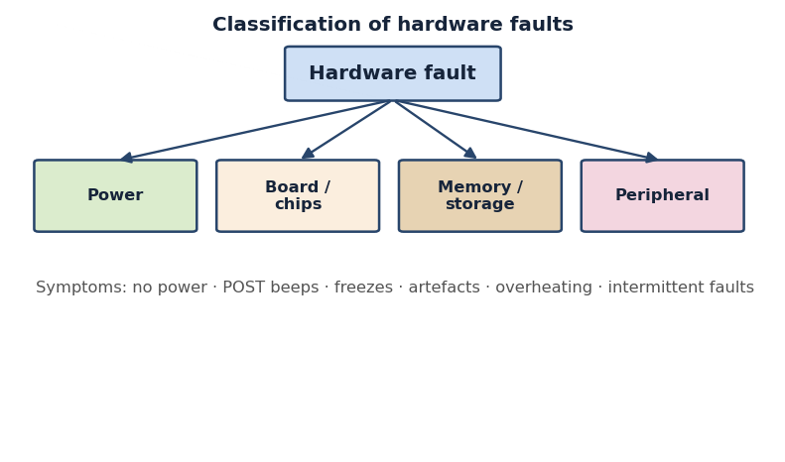
Figure 12. Classification of hardware faults
CL: /1/, /3/.
Self-assessment questions:
1. What is the difference between permanent, intermittent and degradation faults, and which is hardest to diagnose?
2. List the main subsystems of a computer used to classify hardware faults and give one typical fault for each.
3. What does the absence of any signs of life (no fans, no lights, no display) most often indicate?
4. How do POST beep codes and diagnostic LEDs help to localise a fault during startup?
5. Why can a single failing power supply produce symptoms that imitate several different component faults?

Lecture No. 17
Topic: Diagnostic Methods: Visual Inspection, POST Diagnostics and the Substitution Method
Plan:
1. Structured visual and sensory inspection of a faulty system
2. POST diagnostics with beep codes, POST cards and firmware indicators
3. The substitution method and the principle of fault isolation

Once a fault has been classified, the technician must apply concrete methods to locate it. Three classical techniques form the backbone of hardware diagnosis: visual inspection, POST-based diagnostics, and the substitution or part-swapping method. These methods require little special equipment, work on almost any system, and complement one another. Used together in a disciplined sequence, they isolate the great majority of hardware faults before any advanced instrument is needed. This lecture explains how each method works, what kind of fault it reveals, and how to combine them into a coherent troubleshooting routine that minimises wasted effort and avoids damaging good components.
Visual inspection is always the first step because it is fast, free and risk-free, and because a surprising number of faults betray themselves to the senses. With the machine safely powered off and unplugged, the technician opens the case and examines every component in good light. The classic targets are electrolytic capacitors that have bulged, leaked or vented; scorch marks or melted plastic near the voltage regulators and power connectors; and a motherboard battery that has swollen or leaked. Connectors deserve special attention: power leads, data cables and expansion cards that are loose, bent or corroded cause many intermittent faults. The technician also checks that fans spin freely and are not clogged with dust and that heatsinks are firmly seated. The senses of smell and touch add information too: the acrid odour of burnt components and, on a running machine, abnormally hot spots both point directly to trouble.
When visual inspection does not reveal the fault, the machine's own power-on self-test becomes the primary diagnostic tool. POST diagnostics rely on the firmware's habit of testing critical components in sequence and reporting failures before the operating system loads. The technician powers the system on and observes how far the POST proceeds. If the firmware halts and emits a beep code, the pattern of beeps identifies the failing subsystem according to the vendor's documented table; a repeating pattern for memory, for example, tells the technician to focus on the RAM and its slots. Modern boards add diagnostic LEDs and two-digit POST displays that show, with even greater precision, whether the system stopped at the CPU, the DRAM, the graphics adapter or the boot device.
For systems that produce no beep and no on-board display, a dedicated POST diagnostic card extends the method. The card plugs into an expansion slot, usually PCI or PCI Express, and shows the hexadecimal code of the last POST step the firmware attempted. Because the firmware writes a known code to a fixed port before each stage of the self-test, the last code displayed reveals exactly where the process stalled. A board frozen at a memory-test code directs attention to the RAM, while a stall at an early chipset-initialisation code points to the processor or the board itself. The POST card is inexpensive and turns an otherwise silent, dead-looking machine into one that explains precisely which stage of startup failed, making it one of the most valuable tools a technician can own.
The third classical method is substitution, also called the swap test, which embodies the broader principle of fault isolation. The idea is simple: when a component is suspected, replace it with a known-good identical part and observe whether the symptom disappears. If swapping the memory module cures the fault, the original module was defective; if the fault persists, the memory is exonerated and attention moves elsewhere. Substitution is especially powerful for parts that are easy to remove and for which spares are available, such as RAM, power supplies, graphics cards and storage drives. It converts an uncertain hypothesis into a definite yes-or-no answer, which is exactly what efficient diagnosis requires.
Substitution must be applied with discipline to be trustworthy. The cardinal rule is to change only one variable at a time; swapping two components at once destroys the logical link between cause and effect. Spare parts must genuinely be known-good, because an untested spare can introduce a second fault and mislead the entire investigation. The technician must also respect compatibility, ensuring the substitute matches the original in type, speed and form factor, and must observe anti-static precautions when handling boards and modules. A practical strategy is the minimal-configuration approach: strip the system down to the bare essentials of processor, one memory module, power and a display, confirm that this minimal set powers on, and then add components back one at a time until the faulty one provokes the symptom. This systematic addition is substitution applied to the whole machine.
These three methods form a natural progression that mirrors the troubleshooting routine. The technician begins with visual inspection because it is the cheapest and may solve the problem outright; if the machine still misbehaves, POST diagnostics narrow the fault to a particular stage of startup and therefore to a particular subsystem; and finally substitution confirms the exact component within that subsystem. Each method reduces the size of the search space, so that by the end the technician is testing one specific part rather than guessing among many, and skipping straight to substitution without first inspecting and reading the POST wastes time and risks swapping good components. In practice the methods are woven together as evidence accumulates: a visual clue such as a bulged capacitor near the memory slots suggests where to point the POST analysis, and a POST code pointing at memory tells the technician which component to substitute first. Mastery of visual inspection, POST diagnostics and substitution gives the technician a reliable, low-cost path from broad uncertainty to a single confirmed faulty component, and forms the foundation on which the software-based diagnostic tools studied next are built.
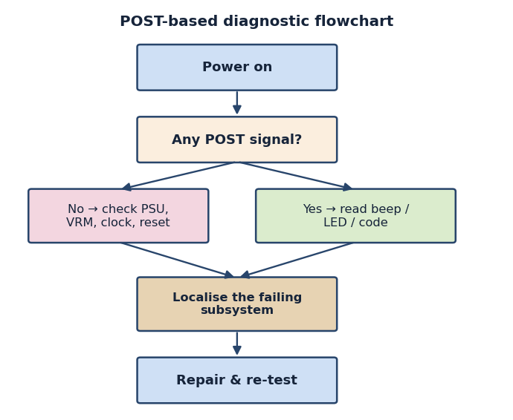
Figure 13. POST-based diagnostic flowchart
Example (commands / script):
# Read hardware inventory to localise a faulty unit
sudo dmidecode -t bios # BIOS/UEFI vendor and version
sudo dmidecode -t memory # installed RAM modules
lspci -nnk # PCI devices and their drivers
lsusb # connected USB devices
sudo journalctl -p err -b # kernel errors since last boot

CL: /1/, /3/.
Self-assessment questions:
1. What specific signs does a technician look for during visual inspection of a powered-off motherboard?
2. How does a POST diagnostic card determine where the startup process has stalled?
3. State the principle of the substitution method and explain why only one component should be changed at a time.
4. Describe the minimal-configuration approach and how it relates to fault isolation.
5. In what order should visual inspection, POST diagnostics and substitution normally be applied, and why?

Lecture No. 18
Topic: Software Diagnostic Tools and Testing of Hardware Components
Plan:
1. The role and limits of software-based hardware diagnostics
2. Tools for testing memory, storage, processor and thermal behaviour
3. Interpreting results, SMART data and stress testing under load

Hardware faults do not always announce themselves with smoke or a halted self-test. Many faults are intermittent or marginal, appearing only under heavy load, at high temperature, or after hours of operation. To catch these elusive defects, the technician turns to software diagnostic tools that exercise the hardware deliberately and report its behaviour in detail. These tools complement the physical methods of the previous lecture: where visual inspection and POST diagnostics find faults that prevent startup, software diagnostics characterise faults in components that start but do not work reliably. This lecture surveys the main categories of diagnostic software and shows how to interpret the results responsibly.
Before discussing specific tools it is important to understand both the power and the limits of software diagnostics. Their great advantage is that they can test a component repeatedly, automatically and under controlled conditions, and can read internal sensors and self-monitoring data that are invisible to physical inspection. Their limitation is that they require the system to boot far enough to run the software, so a completely dead machine cannot be tested this way. Software tools also describe symptoms rather than physical causes; a memory test that reports errors proves the memory subsystem is faulty but cannot, by itself, say whether the module, the slot or the memory controller is to blame. The technician must therefore combine software results with the physical methods already studied.
Memory testing is one of the most valuable applications of diagnostic software, because faulty RAM produces some of the most confusing symptoms in computing, including random crashes, data corruption and intermittent failures to boot. A dedicated memory tester writes carefully chosen bit patterns to every accessible address and reads them back, using patterns designed to expose stuck bits, addressing faults and interactions between adjacent cells. Because such a test must control all of memory, it usually runs from bootable media before the operating system loads. A single confirmed error is enough to condemn a module, and the technician then uses substitution to determine which of several installed modules is defective. The thoroughness of these tests is essential, since marginal faults can pass a quick check yet fail after many hours, so a serious test is allowed to run for several complete passes.
Storage devices have their own family of diagnostic tools, built around the self-monitoring technology embedded in modern drives. Hard disk drives and solid-state drives continuously record internal health indicators, known collectively as SMART data, which software can read and interpret. For a mechanical hard drive the technician watches the counts of reallocated sectors, pending sectors and read-error rates, because a rising reallocated-sector count is a reliable warning that the drive is failing and that data should be backed up immediately. For solid-state drives the wear-levelling and remaining-life indicators reveal how much of the flash endurance has been consumed. Beyond SMART, surface-scan utilities verify that every sector can be accessed reliably, distinguishing a drive that is merely full or fragmented from one that is physically failing.
The processor and the broader system stability are tested with stress and benchmarking tools that drive the hardware to its limits while monitoring for errors. A processor stress test loads every core to one hundred per cent and checks that the computed results remain correct, which simultaneously exposes calculation errors and forces the chip to its maximum temperature. This is invaluable for diagnosing instability that appears only under load, a classic sign of inadequate cooling or a marginal power supply. Graphics subsystems have analogous stress tests that render demanding scenes to provoke artefacts or crashes. Throughout these tests the technician watches the temperature, voltage and clock-speed sensors, because a processor that throttles its speed or shuts down under load is reporting a thermal or power problem rather than a defect in the silicon itself.
Temperature and electrical monitoring deserve emphasis because thermal problems underlie a large share of intermittent faults. Hardware-monitoring utilities display, in real time, the readings from the temperature sensors on the processor, the graphics card, the chipset and the drives, together with fan speeds and the main supply voltages. By observing how these values change from idle to full load, the technician distinguishes a cooling fault, where temperatures climb dangerously, from a power fault, where a supply rail sags under load. Monitoring also confirms whether a repair has succeeded: after cleaning dust, reseating a heatsink or renewing thermal paste, the same load test should now show temperatures returning to a safe range.
Interpreting diagnostic output is a skill in its own right, and the most common beginner's mistake is to trust a single tool blindly. Results must be read in context: a memory error reported during an unstable, overheating stress test may be a consequence of the heat rather than a genuine memory fault, so the technician first stabilises temperature and then retests. Errors should be reproduced before a component is condemned, because a one-off glitch may have an external cause, and consistency across tools strengthens a diagnosis: when SMART data, a surface scan and the user's reports of corruption all point to the same drive, the conclusion is secure. Documenting the conditions and results keeps the evidence for a replacement decision defensible. In short, software diagnostics cannot replace the physical methods that find faults preventing startup, but they reveal the marginal, load-dependent and time-dependent faults that those methods miss and supply quantitative evidence about the health of memory, storage, processor and cooling, completing the diagnostic toolkit and preparing the ground for the repair operations studied next.
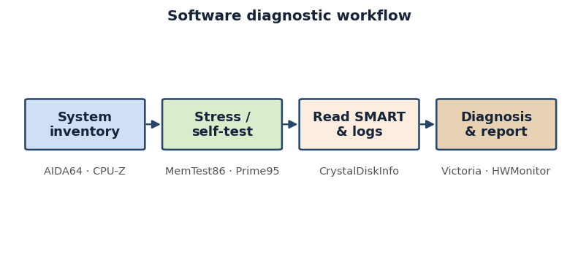
Figure 14. Software diagnostic workflow
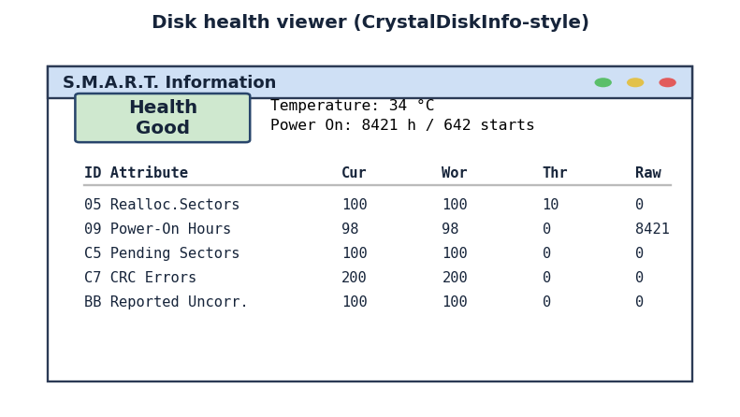
Figure 15. Disk-health (S.M.A.R.T.) viewer interface
Example (commands / script):
# Storage health and self-test
smartctl -a /dev/sda # full SMART attributes
smartctl -t short /dev/sda # start a short self-test

# Memory test (in-OS) and Windows built-in tool
sudo memtester 1024 1 # test 1024 MB, 1 pass
mdsched.exe :: Windows Memory Diagnostic

CL: /1/, /3/.
Self-assessment questions:
1. What kinds of hardware faults are software diagnostic tools especially suited to detect, and why?
2. Why must a thorough memory test usually run from bootable media and for several complete passes?
3. Which SMART indicators warn that a hard disk drive is failing, and what action should they prompt?
4. How does a processor stress test help to distinguish a cooling or power problem from a defect in the chip?
5. Why should a reported diagnostic error be reproduced and cross-checked before a component is replaced?

Lecture No. 19
Topic: Resolving Typical Component Faults and the Order of Repair Operations
Plan:
1. A systematic troubleshooting methodology from symptom to repair
2. Typical faults of the main components and how to remedy them
3. Safe sequencing of repair operations and verification of the result

Diagnosis is only half of the technician's work; the other half is the safe and correct execution of the repair. Once a faulty component has been identified through classification, inspection, POST analysis, substitution and software testing, the technician must decide what action to take, in what order, and how to confirm that the problem is genuinely solved. This final lecture describes a repeatable troubleshooting methodology, surveys the typical faults of the main components and their remedies, and sets out the proper sequence of repair operations together with the step of verifying restored functionality.
A sound repair always follows a methodology rather than improvisation. The accepted sequence begins with gathering information: questioning the user about what changed, when the fault appeared and under what conditions it occurs. The technician then reproduces the fault to observe it directly, forms a hypothesis about the most probable cause based on the symptom and the classification framework, and tests that hypothesis with the least invasive method available. If the hypothesis is confirmed, the repair is carried out; if it is refuted, the technician forms a new hypothesis rather than pressing on blindly. After the repair, the system is tested to confirm the fault is gone and that no new problem has been introduced, and finally the work is documented. This disciplined loop of observe, hypothesise, test, repair and verify prevents the random part-swapping that wastes spares and erodes a workshop's reputation.
Each major component fails in characteristic ways, and knowing these patterns speeds both diagnosis and repair. The power supply unit is among the most common culprits; it fails through worn capacitors, an over-stressed rail or a dead fan, producing dead machines, random restarts and instability under load, and the standard remedy is outright replacement, since opening a supply exposes the technician to stored charge. The motherboard suffers from bulging capacitors, cracked solder joints, damaged sockets and faults in its voltage regulators; minor problems such as a dislodged battery or a loose connector are repairable, but deep faults usually mean board replacement, and a faulty voltage-regulator area in particular often leaves a board that powers on but cannot run the processor.
The processor itself is one of the most reliable components and rarely fails outright, so apparent CPU faults are far more often caused by overheating, bent socket pins or inadequate power delivery than by the chip dying. The usual remedy is therefore not to replace the processor but to restore proper cooling and check the socket and power connections. Memory, by contrast, fails more often and more visibly, producing crashes and corruption; the remedy is to identify the faulty module by substitution and replace it, though a surprising number of memory faults are cured simply by cleaning the contacts and reseating the module firmly in its slot. Recognising that reseating and cleaning resolve many faults saves the needless replacement of healthy parts.
Storage and cooling faults round out the common picture. Hard disk drives fail mechanically and give warning through SMART data, noise and slow access; the only safe response is to back up the data immediately and replace the drive, since a degrading mechanical drive will not recover, while solid-state drives fail more abruptly when their flash endurance is exhausted, again calling for replacement after data recovery. Cooling faults are extremely common and underlie a large share of the instability blamed on other components: clogged heatsinks, seized fans and dried-out thermal paste all cause overheating that manifests as throttling, random shutdowns and load-dependent crashes, yet they are among the cheapest to repair, because cleaning the cooling path and renewing the thermal interface restores normal behaviour.
The order in which repair operations are carried out matters as much as the operations themselves, and it begins with safety. The technician powers down the system, disconnects it from the mains, and, where charge can persist, allows time for it to dissipate before touching internal parts; anti-static precautions are taken throughout to protect sensitive components. The general rule is to attempt the simplest, least invasive and most reversible action first: reseat connectors and modules, clean contacts and cooling surfaces, and only then progress to replacing components, fitting a compatible and known-good part and reconnecting everything correctly. Working from simple to complex and from reversible to permanent keeps risk low and avoids creating new faults during the repair.
No repair is complete until its success has been verified, and verification must be deliberate rather than assumed. The technician powers the system on and confirms that it now completes its self-test and boots normally, then specifically re-creates the conditions under which the original fault appeared. If the fault occurred only under load, the system is stress-tested; if it was thermal, temperatures are monitored under load to confirm they remain safe; if a drive was replaced, its SMART data and a surface scan confirm the new drive is healthy. The technician also checks that the repair has not disturbed anything else, and only when the symptom is gone and the system is stable under realistic conditions is the work declared finished and the actions, parts and results recorded.
Bringing the learning outcome together, competent hardware troubleshooting is a chain in which every link matters. The technician classifies the fault, inspects the machine, reads the POST, isolates the component by substitution, characterises marginal faults with software tools, and finally repairs the confirmed component following a safe, simple-to-complex sequence before verifying the result under realistic load. The recurring professional habits are the same at every stage: change one thing at a time, prefer the reversible action, work safely, and confirm the outcome with evidence rather than hope. A technician who internalises this methodology restores systems to reliable operation without replacing healthy parts.
CL: /1/, /3/.
Self-assessment questions:
1. Describe the steps of the troubleshooting methodology from gathering information to documenting the repair.
2. Why are apparent processor faults usually caused by cooling or power problems rather than by the chip itself?
3. Which faults are best remedied by reseating and cleaning rather than by replacing the component?
4. What safety and sequencing rules govern the order in which repair operations are performed?
5. How should a technician verify that a repair has truly restored the system's functionality?

Lecture No. 20
Topic: Causes and Classification of Hardware and Software Failures
Plan:
1. The concept of a failure: errors, faults, malfunctions and the difference between transient and permanent failures.
2. Hardware failures: their physical causes, typical symptoms and methods of classification.
3. Software failures: logical causes, the role of the operating system and the principles of failure analysis.

A failure is any event in which a computer system stops performing its intended function correctly. To work with failures systematically, a service specialist must distinguish several related concepts. A fault is the underlying physical or logical defect, for example a cracked solder joint or a corrupted configuration file. An error is the incorrect internal state that the fault produces, and a failure is the externally observable deviation of the system from its specification. This chain of cause and effect explains why the same visible symptom, such as an unexpected restart, can originate from completely different roots. The first professional skill in recovery work is therefore not repair itself but accurate classification, because the chosen recovery method depends directly on the category of the problem.
Failures are commonly divided by their persistence in time. A transient failure appears once and disappears, often caused by electrical noise, a momentary voltage dip or a cosmic-ray bit flip in memory; it may never recur. An intermittent failure appears irregularly under specific conditions, such as a contact that loses connection only when the chassis heats up. A permanent failure is stable and reproducible, for example a burned-out voltage regulator. This temporal classification is critical for diagnosis: transient and intermittent faults are the hardest to localise, because they cannot always be reproduced on demand, and they require monitoring, stress testing and event-log analysis rather than a single inspection.
Hardware failures have physical causes that the technician can usually trace to a component or a circuit. The most frequent are thermal stress and overheating, which degrade semiconductors and dry out thermal paste; power-related damage from unstable mains voltage, surges or failing power-supply capacitors; mechanical wear, especially in hard disk drives, fans and connectors; and ageing of electrolytic capacitors that lose capacity and cause instability. Electrostatic discharge during handling can damage chips invisibly, producing failures that appear only later. Typical symptoms include the system not powering on, random restarts, beep codes during the power-on self-test, video artefacts, disk read errors and burning smells. Recognising the symptom pattern allows the specialist to narrow the search to the power, memory, storage or graphics subsystem.
Software failures arise from logical rather than physical causes, yet they can be just as disruptive and are often mistaken for hardware faults. Their main sources are corruption of system files caused by improper shutdown or disk errors, incompatible or buggy drivers, faulty updates, conflicts between applications competing for the same resources, misconfiguration of the operating system, and malicious software such as viruses and ransomware. A software failure may manifest as a boot loop, a blue or black screen with a stop code, an application that hangs, or data that becomes unreadable. Because the underlying hardware remains healthy, these failures are usually recoverable without replacing parts, through repair tools, rollback mechanisms or reinstallation, which makes correct identification economically important.
Distinguishing hardware from software failures is one of the most valuable diagnostic abilities in this discipline. A practical rule of thumb is that hardware faults tend to be tied to a physical condition, such as temperature, movement or time since power-on, and often persist regardless of the operating system, whereas software faults usually disappear when the system is booted from clean external media. For instance, if a laptop crashes both in Windows and when running a live diagnostic environment from a USB stick, the cause is probably hardware; if it runs perfectly from external media but fails from the installed system, the cause is almost certainly software. Memory tests, disk SMART attributes, temperature monitoring and clean-boot tests are the standard instruments used to separate the two domains.
Beyond persistence and origin, failures can be classified by their severity and impact on the user. A degradation failure leaves the system partly usable, for example reduced performance because one of several memory modules has failed. A complete failure leaves the system inoperable. A data-integrity failure may allow the system to keep running while silently corrupting stored information, which is among the most dangerous categories because it can go unnoticed until backups are also affected. Service organisations frequently combine these dimensions into a criticality matrix that weighs how likely a failure is against how serious its consequences are, and this matrix guides which preventive measures and recovery resources deserve priority.
A disciplined approach to causes and classification underpins everything that follows in this learning outcome. By first identifying whether a problem is hardware or software, transient or permanent, partial or total, the specialist selects the appropriate recovery path: firmware re-flashing, operating-system repair, data restoration or component replacement. Equally important, classification feeds prevention, because recurring categories of failure reveal systemic weaknesses, such as inadequate cooling or unstable power, that can be addressed before the next incident. The remaining lectures of this outcome build on this foundation, examining firmware and system-software recovery, backup and data restoration, and the preventive engineering that reduces the frequency of failures in the first place.
CL: /1/, /3/.
Self-assessment questions:
1. Explain the difference between a fault, an error and a failure, and give an example of each.
2. How do transient, intermittent and permanent failures differ, and why are the first two harder to diagnose?
3. List the main physical causes of hardware failures and a typical symptom for each.
4. What practical test helps determine whether a problem is caused by hardware or software?
5. What is a criticality matrix and how does it help a service organisation prioritise recovery and prevention?

Lecture No. 21
Topic: Recovery of BIOS/UEFI, Firmware and System Software
Plan:
1. The role of BIOS/UEFI firmware, the boot process and the consequences of firmware corruption.
2. Methods of firmware recovery: backup, recovery jumpers, BIOS Flashback, dual-BIOS and SPI programming.
3. Recovery of operating-system software: boot repair, system files and safe rollback procedures.

The BIOS or its modern successor UEFI is the first software a computer runs after power is applied. Stored in a small non-volatile flash chip on the motherboard, this firmware initialises the processor, memory and chipset, performs the power-on self-test, and hands control to the boot loader of the operating system. Because the firmware sits at the very base of the software stack, its corruption is one of the most serious failures a technician can face: a machine with damaged firmware often shows no display at all and appears completely dead. Understanding how firmware is organised and how it can be restored is therefore an essential recovery competence, especially as firmware is increasingly updated to fix bugs, add hardware support and patch security vulnerabilities.
Firmware corruption usually occurs during an update that is interrupted by a power loss, a system crash or the use of an incorrect image. It can also result from a failed overclocking attempt, a malware infection that attacks the firmware, or simple wear of the flash memory. The symptoms range from a system that will not power on at all, to one that powers on but never reaches the self-test, to repeated boot loops. Because the firmware controls the most basic initialisation, the technician cannot rely on the operating system for diagnosis and must instead use motherboard indicators such as debug LEDs, POST-code displays and manufacturer-specific recovery features. Recognising that a fault lies in the firmware rather than in a hardware component is itself a diagnostic achievement.
Prevention is the first line of defence, and the safest practice is to create a backup of the working firmware before any update and to keep a record of the exact board model and firmware version. Many modern motherboards include a dual-BIOS design with a primary and a backup chip, so that if the primary image is damaged the board automatically falls back to the secondary one. Others provide a recovery mode triggered by a jumper or a key combination, which reads a known-good image from a USB device. A particularly useful feature is BIOS Flashback, which lets the user write firmware from a USB stick even when no processor or memory is installed, making it possible to recover a board that otherwise cannot boot at all.
When the built-in mechanisms are unavailable or insufficient, firmware can be restored at the hardware level using an external SPI programmer, often based on inexpensive CH341A hardware, connected directly to the flash chip with a clip or by desoldering it. The technician downloads the correct image from the manufacturer, verifies its checksum, and writes it to the chip. This procedure demands strict accuracy, because flashing an image intended for a different board model can permanently damage the device, and it must be performed with proper antistatic precautions. Although hardware-level recovery is more advanced, it is a valuable skill in a service workshop because it can revive boards that consumer-level tools consider unrecoverable, saving the cost of a full motherboard replacement.
Above the firmware lies the operating system, whose own system software is a frequent and usually more recoverable source of failure. When the operating system will not start, the technician first determines whether the boot loader, the boot configuration or the core system files are at fault. Modern systems provide a built-in recovery environment that can repair the boot loader, rebuild the boot configuration data, run automatic startup repair and offer a command line for manual intervention. Tools that scan and replace damaged protected system files, and commands that repair the underlying system image, allow many failures to be fixed without reinstalling the whole operating system, preserving the user's applications and settings.
When repair is not enough, controlled rollback offers a safer path than full reinstallation. System restore points capture the state of system files, drivers and configuration at a known-good moment, and reverting to such a point can undo damage caused by a bad update or a misbehaving driver while leaving user documents intact. Operating systems also allow recently installed updates and drivers to be uninstalled individually, and they keep a copy of the previous build for a limited period so that a problematic major upgrade can be reversed. Booting into a safe or minimal mode, in which only essential drivers load, is often the gateway that makes these rollback operations possible when the normal environment is unstable.
Throughout all of these techniques, a consistent professional discipline applies: always identify the exact hardware and software versions, always obtain images and tools from the legitimate manufacturer, always verify integrity before writing, and never interrupt a flash operation once it has begun, ideally protecting the procedure with an uninterruptible power supply. The technician should also document each step so that the action can be reversed or repeated if necessary. By combining firmware backup, dual-BIOS and Flashback features, hardware programming, operating-system repair and careful rollback, the specialist can recover a system from the lowest level of corruption upward, restoring it to a working state with minimal loss of data and configuration.
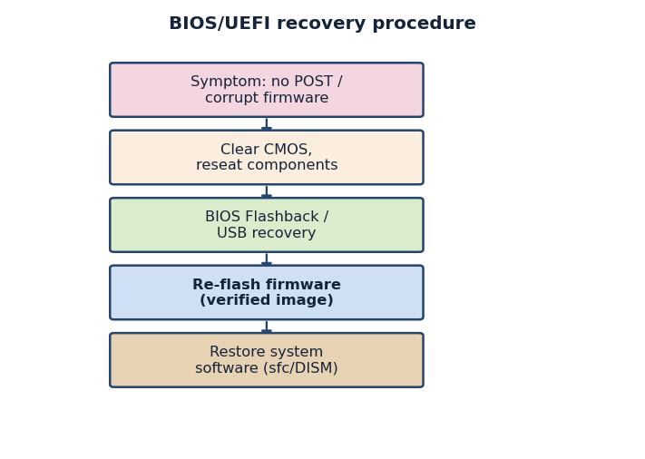
Figure 16. BIOS/UEFI recovery procedure
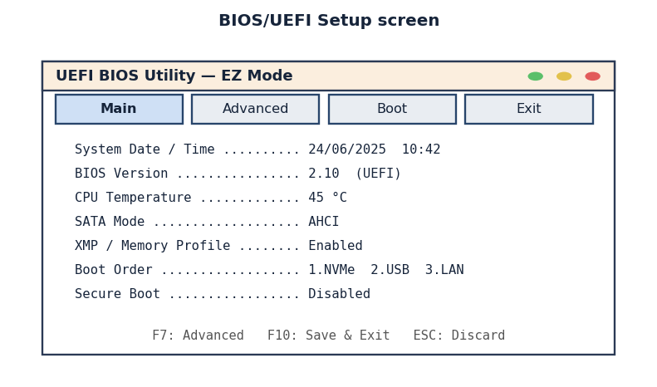
Figure 17. BIOS/UEFI Setup screen
Example (commands / script):
:: Verify and repair protected system files
sfc /scannow
DISM /Online /Cleanup-Image /RestoreHealth

:: Repair boot records (Windows RE command prompt)
bootrec /fixmbr
bootrec /fixboot
bootrec /rebuildbcd

CL: /1/, /3/.
Self-assessment questions:
1. What functions does BIOS/UEFI firmware perform, and why is its corruption so serious?
2. Describe two built-in motherboard mechanisms that allow firmware recovery without external equipment.
3. When and how is an external SPI programmer used, and what precaution prevents permanent damage?
4. Which built-in tools repair a non-booting operating system without a full reinstallation?
5. Explain the difference between a system restore point and an in-place reinstall, and when each is appropriate.

Lecture No. 22
Topic: Backup, Data Recovery and System Imaging
Plan:
1. Backup strategies: full, incremental and differential copies and the 3-2-1 rule.
2. System imaging and bare-metal restore as a means of fast recovery.
3. Data-recovery techniques for deleted, corrupted or physically damaged storage.

Backup is the practice of keeping additional copies of data so that information can be restored after loss, and it is the single most effective safeguard against the consequences of failure. The value of a backup lies not in its creation but in the ability to restore from it reliably, which is why professionals treat an untested backup as no backup at all. Two parameters frame every backup design: the recovery point objective, which defines how much recent data the organisation can afford to lose and therefore how frequently copies must be made, and the recovery time objective, which defines how quickly the system must be back in operation and therefore which restore method is acceptable. These objectives translate business needs into concrete technical decisions about schedules, storage and tools.
Backups are classified by how much data they copy each time. A full backup copies all selected data and is simple to restore from but consumes the most space and time. An incremental backup copies only the data changed since the previous backup of any type, which makes each backup fast and small but requires the full backup and every subsequent increment to restore. A differential backup copies everything changed since the last full backup, occupying a middle ground: larger than an incremental but needing only the full backup plus one differential to restore. Service specialists combine these types into schedules, for example a weekly full backup with daily incrementals, balancing storage cost against restore complexity.
A widely taught guideline is the 3-2-1 rule: keep at least three copies of important data, store them on at least two different types of media, and keep at least one copy off-site. The rule protects against the realistic ways backups fail together, such as a single drive failing, a fire or flood destroying everything in one room, or ransomware encrypting all locally connected copies at once. Modern practice often extends the rule with an additional offline or immutable copy that malware cannot alter, recognising that backups themselves are now a target of attack. The discipline of separating copies in space and in media type is what turns a backup from a convenience into genuine protection against disaster.
Beyond copying individual files, a system image captures the entire contents of a drive, including the operating system, applications, settings and data, as a single restorable unit. Imaging is the foundation of fast recovery because it enables a bare-metal restore, in which a failed or replaced disk is returned to a fully working state in one operation rather than by reinstalling the operating system and every application by hand. This approach dramatically reduces recovery time after a catastrophic failure, and it is also valuable for deploying identical configurations across many machines. The technician must store images on separate media, label them with the date and machine, and periodically verify that they can actually be restored to compatible hardware.
When data is lost without a usable backup, recovery techniques attempt to retrieve it from the storage device itself. The simplest case is accidental deletion, where the file's contents often remain on the disk until overwritten, so the first and most important action is to stop using the affected drive immediately to avoid destroying the recoverable data. Specialised software can scan the medium for residual file structures and reconstruct deleted or lost files, and file-system repair tools can fix logical corruption of partition tables and directories. Working from a copy or image of the failing drive, rather than the original, is a basic professional precaution that prevents a single mistake from making the situation irreversible.
Physical damage to storage presents the most difficult recovery scenario and marks the boundary of in-workshop service. A hard disk with failing read heads or a drive that suffered shock or water damage may require a cleanroom environment and specialised equipment, and attempting amateur repair usually destroys any remaining chance of recovery. Solid-state drives add their own challenges, because the operating system's trim command and the drive's wear-levelling can permanently erase deleted data far faster than on magnetic media. The professional skill here is to recognise the limit of what can safely be attempted, to preserve the device in its current state, and to advise the customer when a specialised data-recovery laboratory is the appropriate next step rather than risking the data with further attempts.
Effective recovery from data loss is ultimately a matter of preparation rather than heroics. A specialist who has established a sound backup strategy, maintained verified system images and understood the basic principles of data recovery can return a failed system to service quickly and with minimal loss, whereas an organisation that relied on luck faces expensive specialist recovery or permanent loss. The recurring professional themes are to plan backups around clear recovery objectives, to separate copies according to the 3-2-1 rule, to test restoration regularly, and to act cautiously and reversibly when recovering data from a damaged device. These habits transform the inevitable occurrence of failures from disasters into manageable, routine service events.
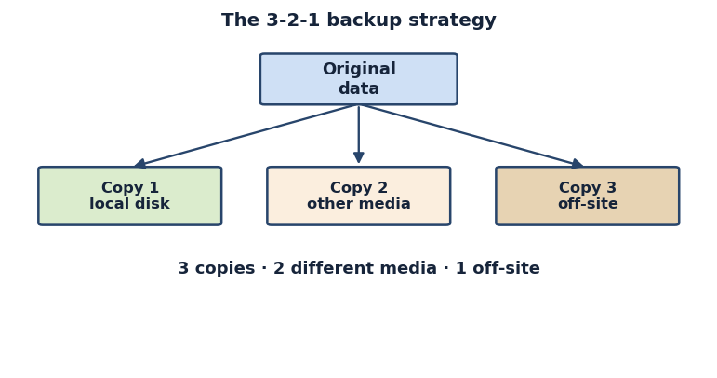
Figure 18. The 3-2-1 backup strategy
Example (commands / script):
:: Windows — full system image backup
wbadmin start backup -backupTarget:E: -include:C: \
-allCritical -quiet

# Linux — clone a disk to an image file
sudo dd if=/dev/sda of=/mnt/backup/disk.img bs=4M \
status=progress

:: Windows — incremental mirror copy of a data folder
robocopy C:\Data E:\Backup\Data /MIR /R:2 /W:5

CL: /1/, /3/.
Self-assessment questions:
1. Define the recovery point objective and the recovery time objective and explain how they influence backup design.
2. Compare full, incremental and differential backups in terms of storage, speed and restore complexity.
3. State the 3-2-1 backup rule and explain which kinds of disaster each part of it protects against.
4. What is a bare-metal restore, and why does system imaging make recovery faster after a catastrophic failure?
5. Why is the correct first response to accidental file deletion to stop using the affected drive immediately?

Lecture No. 23
Topic: Failure Prevention: Power Stabilisation, Cooling, Updates and Monitoring
Plan:
1. Power protection: surge protection, voltage stabilisation and uninterruptible power supplies.
2. Thermal management, dust control and preventive physical maintenance.
3. Updates, monitoring and redundancy as proactive measures within a disaster-recovery plan.

Prevention is more economical and far less disruptive than recovery, and a competent service specialist therefore devotes deliberate effort to stopping failures before they occur. Preventive work rests on the understanding that most failures are not random but are driven by recurring stresses: unstable electrical power, excessive heat, accumulated contamination, ageing components and unpatched software defects. By systematically controlling each of these stresses, the technician extends the service life of equipment and reduces the frequency and severity of incidents. This final lecture of the learning outcome draws the preventive themes together into a coherent maintenance and disaster-recovery practice that complements the recovery techniques studied earlier.
Electrical power is one of the most common causes of hardware failure, so power protection is a foundation of prevention. A simple surge protector diverts transient voltage spikes, for example from lightning or switching events, that would otherwise damage power supplies and motherboards. A voltage stabiliser, or automatic voltage regulator, corrects sustained under-voltage and over-voltage conditions common in unreliable mains supplies, keeping the input within the safe range the equipment expects. The most complete protection is an uninterruptible power supply, which combines surge protection and regulation with a battery that maintains power during outages. The UPS prevents the abrupt shutdowns that corrupt file systems and interrupt firmware updates, and it gives the system time to save data and shut down cleanly, making it indispensable for servers and critical workstations.
Heat is the second great enemy of reliability, because elevated temperatures accelerate the ageing of every semiconductor and shorten the life of capacitors and drives. Thermal management therefore aims to remove heat efficiently and to keep components within their rated operating range. This involves ensuring adequate airflow through a correctly arranged set of intake and exhaust fans, maintaining functional heat sinks and replacing dried thermal paste between processors and their coolers, and verifying that cooling devices actually spin and are not obstructed. Server rooms add room-level climate control and careful airflow planning. Monitoring temperatures continuously allows the technician to detect a failing fan or a rising thermal trend before it causes an overheating shutdown or permanent damage.
Closely related to cooling is the control of dust and physical contamination, which insulates components, clogs fans and filters, and over time produces both overheating and electrical problems. Scheduled preventive maintenance includes cleaning interior surfaces and fans with compressed air, checking and cleaning intake filters, inspecting cables and connectors for looseness or wear, and confirming that mechanical parts move freely. Performing this work on a regular calendar, rather than waiting for symptoms, keeps small issues from growing into failures. Each maintenance visit is also an opportunity to inspect for early warning signs such as bulging capacitors, discoloured connectors or unusual noises, allowing components to be replaced proactively during planned downtime rather than after an unexpected breakdown.
Software requires its own preventive regime, centred on disciplined updating. Operating-system and application updates fix defects that cause crashes and close security vulnerabilities that malware exploits, so keeping systems patched prevents a large class of software failures. At the same time, updates can themselves introduce problems, which is why the professional practice is to apply updates in a controlled way, to test important updates before wide deployment, and to ensure a backup or restore point exists beforehand so that a faulty update can be reversed. Antivirus and anti-malware protection, combined with firewalls and cautious user behaviour, prevents the malicious-software failures that are among the most damaging and that can otherwise compromise both the system and its backups.
Monitoring turns prevention from a periodic activity into a continuous one, because it provides early warning of developing problems. Hardware self-monitoring, such as the SMART attributes reported by storage drives, can reveal a disk that is beginning to fail while it is still readable, giving the technician time to migrate the data before total loss. Software tools track temperatures, fan speeds, voltages, memory errors and system event logs, and the event log in particular records the warnings and errors that precede many failures. By reviewing these indicators regularly and setting alerts on critical thresholds, the specialist intervenes proactively, replacing a deteriorating component or correcting a developing fault during planned maintenance instead of responding to an emergency.
All of these measures find their fullest expression in redundancy and a written disaster-recovery plan. Redundancy removes single points of failure: redundant disks in a fault-tolerant array allow a drive to fail without data loss, redundant power supplies and network paths keep critical systems running, and spare parts on hand shorten repair time. A disaster-recovery plan documents in advance how the organisation will respond to major incidents, defining responsibilities, recovery objectives, backup locations and step-by-step restoration procedures, and it is validated by periodic testing. Together, power protection, thermal and physical maintenance, disciplined updating, continuous monitoring and planned redundancy form a complete preventive strategy that minimises failures and ensures that, when they do occur, recovery is fast, orderly and reliable.
CL: /1/, /3/.
Self-assessment questions:
1. Compare a surge protector, a voltage stabiliser and a UPS, and explain what each protects against.
2. Why does heat shorten equipment life, and what specific actions make up effective thermal management?
3. Describe the tasks included in scheduled preventive physical maintenance of a computer.
4. Why must updates be applied in a controlled way, and what safeguard should exist before installing them?
5. How do hardware self-monitoring and redundancy help prevent unplanned downtime and data loss?

Lecture No. 24
Topic: Types of consumables used in computing and office equipment
Plan:
1. The concept of a consumable and its place in the equipment lifecycle
2. Classification of consumables for computers and office equipment
3. Specifications, compatibility and inventory planning of consumables

A consumable, or consumable material, is any item that is depleted, worn out or used up during the normal operation of computing and office equipment and must be replenished or replaced periodically. Unlike durable spare parts that remain in service for the whole life of a device, consumables have a limited working resource expressed in pages printed, hours of operation, number of cycles or a calendar shelf life. Understanding consumables is essential for a maintenance technician because the availability, correct selection and timely replacement of these materials directly determine whether an office can keep working without interruption. A printer that runs out of toner, a UPS with an exhausted battery or a server room without spare cleaning wipes all represent a stoppage that the technician is expected to prevent through planning.
Consumables can be divided into several broad groups according to the equipment they serve. The first and largest group covers printing and imaging supplies: toner cartridges and toner powder for laser printers, ink cartridges and bulk ink for inkjet devices, ribbons for dot-matrix and thermal-transfer printers, thermal film and thermal paper for fax machines and receipt printers, photoconductor drums, developer, fuser units and transfer belts. A second group includes media and recording materials such as plain and specialty paper, labels, photo paper, optical discs and, historically, magnetic tapes used for backup. These media are consumed by the act of recording or printing information onto them.
A third group consists of power and energy related consumables, the most important being the rechargeable batteries of uninterruptible power supplies, laptops and the small lithium cells (CR2032) that maintain the real-time clock and CMOS settings on motherboards. Although a battery is sometimes treated as a spare part, its predictable degradation over charge cycles places it firmly in the consumable category for planning purposes. A fourth group covers cleaning and maintenance materials: lint-free wipes, isopropyl alcohol, compressed air dusters, contact cleaners, thermal paste applied between processors and heat sinks, and the lubricants and cleaning sheets supplied in printer maintenance kits.
A fifth group, smaller but still significant, includes auxiliary office consumables that the same technician is often asked to manage: staples and binding combs for finishing equipment, shredder oil, laminating pouches, stamp pads and the small fasteners used to assemble and service hardware. Treating all these items under one inventory discipline helps an enterprise avoid the situation where an inexpensive missing item idles an expensive machine. Each consumable carries a manufacturer specification: a part number, a stated yield or resource, storage conditions and an expiry date. The technician must read and trust these specifications rather than rely on appearance alone, because two visually similar cartridges may differ in chip firmware, page yield or chemical formulation.
Compatibility is one of the most practical aspects of consumable management. Manufacturers produce original equipment manufacturer (OEM) consumables designed specifically for their devices, while third-party vendors offer compatible and remanufactured alternatives that are usually cheaper. OEM items guarantee declared quality and warranty coverage but cost more; compatible items reduce expenditure but may vary in reliability and can, in some printers, trigger warnings or refuse to operate if the embedded chip is not recognised. A competent technician weighs cost against risk, checks the device model and the exact cartridge family, and verifies regional and firmware compatibility before ordering. Choosing the wrong toner series or an ink set with mismatched colour chemistry can damage a print head or void a warranty.
Resource planning turns this knowledge into a working system. For every device in the fleet the technician records the consumable types it uses, their rated yields and the average monthly load. From these figures a consumption norm is derived — for example, a department printing roughly four thousand pages a month with a cartridge rated for two thousand pages will need about two cartridges monthly, plus a safety stock to cover demand peaks and delivery delays. Such norms feed a procurement schedule and a minimum reorder level, so that replacements are ordered before the existing stock is exhausted. Software counters built into modern printers and centralised print-management systems report remaining toner levels and page counts, allowing consumption to be tracked automatically.
Correct storage protects the value of stored consumables. Toner and ink are sensitive to heat, humidity and light; cartridges should be kept in their sealed packaging, stored upright in a cool dry place and used within their shelf life, because dried ink and clumped toner cause poor print quality and printer faults. Batteries should be stored partly charged at moderate temperatures and rotated so that the oldest stock is used first, following the first-in first-out principle. Paper must be kept dry and flat to prevent jams. A well-organised consumables store, labelled by device and part number with clear records of receipts and issues, is the foundation on which reliable replacement and accounting are built.
In summary, consumables form a distinct and economically important category of materials that keep computing and office equipment operational. The technician who can classify them correctly, read their specifications, judge compatibility, calculate consumption norms and store them properly is able to guarantee continuity of service at controlled cost. The remaining lectures of this learning outcome build on this foundation: the next examines the consumables of printing devices in detail, and the third addresses the procedures for replacing, accounting for and disposing of used materials safely and lawfully.
CL: /1/, /3/.
Self-assessment questions:
1. What is a consumable, and how does it differ from a durable spare part?
2. List the main groups into which consumables for computing and office equipment are classified.
3. What is the difference between OEM and compatible consumables, and what risks does each carry?
4. How is a monthly consumption norm for a consumable calculated, and why is a safety stock needed?
5. Which storage conditions protect toner, ink, batteries and paper from premature degradation?

Lecture No. 25
Topic: Consumables of printing devices: cartridges, toner, ink and photoconductor drums
Plan:
1. Laser printing consumables: toner, cartridges, drums and fuser units
2. Inkjet printing consumables: ink cartridges, bulk ink and print heads
3. Thermal, dot-matrix and other media; quality factors and yield

Printing devices are the office machines that consume materials most intensively, so their consumables deserve detailed study. The dominant printing technologies in modern offices are laser (electrophotographic) and inkjet, each with its own family of consumables, supplemented by thermal and dot-matrix printers in specialised roles such as receipts, labels and multi-part forms. A maintenance technician must understand what each technology consumes, how the consumable behaves inside the machine and what signs indicate that replacement is due, because the wrong material or a late replacement degrades print quality and can damage the device.
In a laser printer the central consumable is toner, a fine powder of pigment and plastic particles that is charged, transferred to the paper by an electrostatic image and then fused by heat and pressure. Toner is supplied either inside a self-contained cartridge that also houses the photoconductor drum, or, in higher-volume machines, as a separate toner bottle paired with a long-life drum unit. The photoconductor drum is a light-sensitive cylinder that forms the latent image; it wears gradually and is rated for tens of thousands of pages, so on many devices it is replaced less often than the toner. Additional laser consumables include the developer unit, the transfer belt or roller and the fuser unit, the heated assembly that bonds toner to paper and which itself has a service-life rating. Recognising which of these is integrated into the cartridge and which is separate is essential for ordering the right part.
Inkjet printers form characters by spraying microscopic droplets of liquid ink through a print head. Their primary consumable is ink, supplied as individual colour cartridges, as combined tri-colour cartridges, or as bulk bottles for refillable continuous-ink supply systems that have become popular for high-volume, low-cost printing. In some designs the print head is built into the cartridge and is renewed with every replacement, while in others the head is a permanent part of the printer and must be protected from clogging. Because liquid ink dries, inkjet devices are prone to blocked nozzles if left idle, and most include a cleaning cycle that itself consumes a small amount of ink. The technician must distinguish dye-based ink, which gives vivid colour, from pigment ink, which is more durable and water resistant, and must never mix incompatible ink chemistries.
Thermal printers come in two kinds. Direct-thermal printers use heat-sensitive paper that darkens under a heated head and require no ink or toner, only the special thermal paper, which fades over time and is therefore unsuitable for permanent records. Thermal-transfer printers use a wax or resin ribbon, the thermal film, which is melted onto ordinary media to produce durable labels and barcodes; here both the ribbon and the label stock are consumables. Dot-matrix printers, still used for multi-part invoices and continuous stationery, consume an inked fabric ribbon contained in a cartridge. Knowing these distinctions prevents the common error of loading the wrong media, such as feeding plain paper into a direct-thermal device or fitting an incompatible ribbon.
Several factors determine print quality and the effective yield of a consumable. The declared page yield is measured under a standard test pattern, typically five per cent page coverage, so heavy graphics or large solid areas consume material far faster than the rated figure suggests. Temperature, humidity and the type of paper also affect results: damp paper causes toner to adhere poorly and ink to feather, while overly heavy or coated stock can jam a fuser. The technician should interpret yield figures as planning estimates rather than guarantees and should educate users that draft mode, duplex printing and grayscale settings extend consumable life considerably.
Diagnosing consumable-related faults is a core skill. Faded or light printing often signals low toner or ink, and on laser printers gently redistributing toner by rocking the cartridge can extend its life briefly until a replacement arrives. Repeated marks, streaks or ghosting at fixed intervals usually indicate a worn drum or a dirty transfer roller rather than empty toner. Horizontal white lines or missing colours on inkjets point to clogged nozzles, addressed by a cleaning cycle or head alignment. Smudging that wipes off the page suggests a failing fuser. Correctly attributing a symptom to the right consumable avoids the waste of replacing a full cartridge when the real culprit is the drum or fuser.
Quality and reliability also depend on the source of the consumable. Original cartridges are engineered and tested for the specific printer and carry the manufacturer warranty, whereas refilled or remanufactured cartridges lower cost but vary in consistency and may leak toner or exhaust prematurely. Some printers read an electronic chip on the cartridge that records usage and may reject unrecognised chips; the technician must be aware of this when fitting compatible supplies and should reset or replace chips only where the manufacturer permits. In every case the printed page is the ultimate test: any new consumable should be verified with a test print immediately after installation.
To conclude, the consumables of printing devices are diverse and technology-specific, ranging from laser toner, drums and fuser units to inkjet ink and print heads, thermal film and dot-matrix ribbons. A technician who understands how each is consumed, can read yield specifications critically, can match symptoms to the responsible material and can judge the trade-off between original and compatible supplies will keep an office's printers producing clean output at predictable cost. The final lecture of this outcome turns from understanding these materials to the practical procedures of replacing them, recording their use and disposing of the spent items safely.
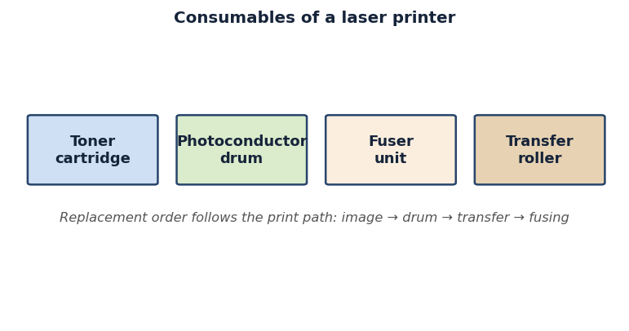
Figure 19. Consumables of a laser printer
CL: /1/, /3/.
Self-assessment questions:
1. Which consumables does a laser printer use, and what is the function of the photoconductor drum and the fuser unit?
2. How do ink cartridges with an integrated print head differ from systems with a permanent head, and why are inkjets prone to clogging?
3. Explain the difference between direct-thermal and thermal-transfer printing in terms of their consumables.
4. Why does the declared page yield differ from real consumption, and which settings extend consumable life?
5. How can the technician tell whether faded or streaked printing is caused by empty toner, a worn drum or a clogged nozzle?

Lecture No. 26
Topic: Procedures for replacing, accounting for and disposing of consumables
Plan:
1. Safe procedure for replacing cartridges and maintenance kits
2. Accounting, recording and inventory control of consumables
3. Recycling, safe disposal and environmental regulations

Knowing what consumables exist is only useful when paired with the disciplined procedures for replacing, recording and disposing of them. These procedures protect the equipment, the operator and the environment, and they ensure that an enterprise can account for its expenditure. This lecture treats the practical workflow that a maintenance technician follows from the moment a consumable runs low to the moment the spent item is safely removed from the premises, together with the documentation and legal requirements that accompany each step.
Replacement begins with preparation and safety. The technician confirms the exact part required, checks that the new consumable matches the device model and is within its shelf life, and gathers protective gloves and, where toner dust is involved, eye protection. Before opening a laser printer the machine should be powered down and allowed to cool, because the fuser operates at a high temperature and can cause burns. Toner cartridges must be handled gently and never opened forcibly, since spilled toner is an irritant; antistatic precautions apply when the work is near exposed electronics. For inkjet devices the printer is usually left on so that the carriage moves to the replacement position, and the technician avoids touching the print-head contacts or nozzles.
The replacement itself follows the manufacturer's documented sequence. The exhausted cartridge is released and withdrawn, the new one is unpacked and freed of its protective tape and sealing strips, and, for laser toner, it is gently rocked to distribute the powder evenly before insertion. The consumable is seated until it locks, covers are closed and the device is allowed to run its initialisation or alignment routine. A maintenance kit, supplied for higher-volume printers, bundles wear parts such as rollers, separation pads and a fuser, and is fitted at a defined page count; after installing it the technician resets the maintenance counter so that the machine reports remaining life correctly. Every installation is verified with a test print or self-test page, and the print quality and alignment are checked before the device is returned to the user.
Accounting and inventory control turn individual replacements into a managed process. Each issue of a consumable from the store is recorded against the device or department that received it, noting the date, part number, quantity and the technician responsible. These records support the consumption norms discussed earlier, reveal abnormal usage that may indicate a faulty device or misuse, and provide the audit trail required for budgeting and procurement. A minimum stock level is maintained for each item, and when stock falls to the reorder point a replenishment order is raised. Modern fleets use print-management and asset-tracking software that links automatically reported page counts and toner levels to the inventory system, so that orders can be triggered before a shortage occurs and costs can be allocated accurately to cost centres.
Proper documentation also covers the used items. A spent cartridge is not simply discarded; it is logged as removed, and its disposal route is recorded. This closes the accounting loop and is increasingly required by environmental and corporate-responsibility policies that demand evidence of how waste is handled. Where an organisation operates a cartridge-return or remanufacturing scheme, the returned units are counted and may even generate a credit, turning a waste stream into a small recovery of value.
Disposal and recycling are governed by environmental considerations because many consumables contain materials that are harmful if discarded carelessly. Toner powder is a fine particulate that should not be inhaled or released into the air, ink contains chemical pigments and solvents, and batteries from a UPS or laptop contain heavy metals and reactive chemistry that make them hazardous waste. Plastics in cartridge bodies are recyclable but slow to degrade. For these reasons spent consumables should never be thrown into ordinary refuse; they are collected separately and handed to authorised recyclers or returned to the manufacturer through take-back programmes. Many vendors supply prepaid envelopes or collection boxes specifically for empty cartridges.
Legal and regulatory frameworks formalise these obligations. International producer-responsibility schemes and national waste-electrical and electronic-equipment rules, together with the corresponding regulations of the Republic of Kazakhstan on the handling of production and consumption waste, require organisations to segregate hazardous consumables, to keep records of their disposal and to use licensed contractors for hazardous fractions such as batteries. The technician should know which categories the workplace treats as hazardous, where the designated collection points are and what documentation a disposal contractor must provide. Following these rules protects the enterprise from penalties and protects the wider environment from contamination.
In conclusion, the safe and accountable management of consumables rests on three linked disciplines: a careful, manufacturer-conformant replacement procedure that protects equipment and operator; an accurate accounting and inventory system that controls cost and triggers timely reordering; and a lawful disposal practice that recycles what it can and routes hazardous waste to authorised handlers. Mastery of these procedures completes the competence of replacing consumables in computing and office equipment, allowing the technician to sustain reliable operation while meeting economic and environmental responsibilities. This knowledge is consolidated in the independent work of this outcome, where students compile consumption norms, study replacement instructions and prepare a formal report on consumable replacement.
CL: /1/, /3/.
Self-assessment questions:
1. What safety precautions must be observed before and during the replacement of a laser toner cartridge?
2. Describe the correct sequence for installing a new cartridge and a printer maintenance kit, including counter reset and verification.
3. Why are consumable issues and removals recorded, and how does inventory control trigger reordering?
4. Which consumables are considered hazardous waste, and why must they not be placed in ordinary refuse?
5. What legal and environmental obligations govern the disposal and recycling of used consumables?

IV. PRACTICAL CLASSES

Practical Class No. 1
Topic: Organizing a safe workspace and using PPE during PC disassembly
Objective of the work: to organize a workplace that complies with occupational safety norms and to apply personal protective equipment when disassembling a personal computer
Theoretical introduction:
Maintenance of computer hardware is performed at a workstation that must meet occupational safety, sanitary and ergonomic requirements. Before any disassembly the technician disconnects the power supply, discharges residual voltage and grounds the equipment to remove the risk of electric shock. An antistatic wrist strap and an ESD mat protect sensitive components such as the CPU, RAM and chipset from static discharge. Personal protective equipment (PPE) and a properly lit, uncluttered desk reduce the probability of injury and accidental damage to parts. Compliance with these rules is the foundation of professional work in information service enterprises.
Materials needed:
Personal computer, web browser with developer tools, VS Code editor, Internet access.
Key questions:
1. Which steps are mandatory before opening the case of a powered computer?
2. How does an antistatic wrist strap protect electronic components during assembly?
Instructions for completion (steps):
1. Arrange the workplace: prepare an ESD mat, tools, lighting and free the work surface from foreign objects.
2. Put on PPE, connect the antistatic wrist strap to ground and disconnect the PC from the mains.
3. Open the system unit case, remove an expansion card and reinstall it observing all ESD precautions.
Guidelines:
Always disconnect power and ground yourself before touching internal components; record each safety step you perform.
Assessment Criteria
Criteria | Max Points | Score
1. Correct workplace organization and ESD setup | 40
2. Proper use of PPE and grounding | 30
3. Accurate component removal and reinstallation | 20
4. Answers to questions | 10
Total Score: _______ / 100
Grade: ____________________
CL: /1/.

Practical Class No. 2
Topic: Drilling responses to electric shock and equipment fire
Objective of the work: to practise the algorithm of actions in case of electric shock and ignition of computer equipment
Theoretical introduction:
Working with computer hardware always carries the risk of electric shock and fire from faulty power circuits. A technician must know how to de-energize equipment quickly and free a victim from the current source without becoming a casualty. Energized electronics must never be extinguished with water; a carbon dioxide or powder extinguisher of the correct class is required. The sequence of first aid - assessing the situation, removing the hazard, calling for help and providing aid - can save a life. Rehearsing these algorithms turns theoretical safety knowledge into automatic, reliable actions.
Materials needed:
Personal computer, web browser with developer tools, VS Code editor, Internet access.
Key questions:
1. What must be done first when a person is in contact with a live conductor?
2. Which type of fire extinguisher is suitable for energized electronic equipment and why?
Instructions for completion (steps):
1. Demonstrate the procedure for de-energizing equipment and freeing a victim from the current source.
2. Show the correct use of a CO2/powder extinguisher on a simulated equipment fire.
3. Reproduce the first-aid algorithm for an electric-shock victim step by step.
Guidelines:
Follow the de-energize -> protect yourself -> render aid -> call help sequence; never apply water to live equipment.
Assessment Criteria
Criteria | Max Points | Score
1. Correct de-energizing and rescue actions | 40
2. Proper extinguisher selection and use | 30
3. Accurate first-aid algorithm | 20
4. Answers to questions | 10
Total Score: _______ / 100
Grade: ____________________
CL: /1/.

Practical Class No. 3
Topic: Measuring power-supply voltages with a multimeter
Objective of the work: to measure the output voltages of a PC power supply and evaluate their compliance with the standard
Theoretical introduction:
The ATX power supply converts mains voltage into stabilized DC rails of +3.3 V, +5 V and +12 V that feed every node of the computer. A digital multimeter set to DC voltage is the primary instrument for verifying these rails on the 24-pin and CPU connectors. Each rail has an allowed tolerance, typically +/-5%, beyond which instability or hardware damage may occur. Correct probe placement - black to ground (COM), red to the measured pin - is essential for a valid reading. Comparing measured values with the ATX specification lets the technician judge whether the power supply is serviceable.
Materials needed:
Personal computer, web browser with developer tools, VS Code editor, Internet access.
Key questions:
1. Which connector pins carry the +3.3 V, +5 V and +12 V rails on an ATX supply?
2. What voltage tolerance is normally acceptable for ATX rails?
Instructions for completion (steps):
1. Set the multimeter to the DC voltage range and identify ground and rail pins on the 24-pin connector.
2. Measure the +3.3 V, +5 V and +12 V rails and record the readings in a table.
3. Compare the measured values with the ATX tolerance and conclude whether the PSU is within norm.
Guidelines:
Keep the black probe on a ground pin and probe rails one at a time; do not short adjacent pins.
Assessment Criteria
Criteria | Max Points | Score
1. Correct measurement of all rails | 40
2. Proper multimeter setup and probe placement | 30
3. Accurate comparison with the standard | 20
4. Answers to questions | 10
Total Score: _______ / 100
Grade: ____________________
CL: /1/.

Practical Class No. 4
Topic: Checking motherboard circuits and locating a short circuit
Objective of the work: to check the power circuits of a motherboard and detect a short circuit
Theoretical introduction:
The motherboard distributes power and signals between the CPU, memory, chipset and expansion slots through many supply rails formed by VRM circuits. A short circuit in these rails prevents the board from starting and may damage components if power is applied. A multimeter in continuity or resistance mode lets the technician check rails against ground without powering the board. A very low resistance to ground on a rail that should be isolated indicates a short, often caused by a failed capacitor or MOSFET. Systematic measurement of key points narrows the search to the defective area of the board.
Materials needed:
Personal computer, web browser with developer tools, VS Code editor, Internet access.
Key questions:
1. How is continuity/resistance measurement used to find a short circuit on a power rail?
2. Which components most often cause shorts in motherboard power circuits?
Instructions for completion (steps):
1. Set the multimeter to resistance/continuity mode and identify the main supply rails near the CPU socket.
2. Measure the resistance of each rail to ground and record the values.
3. Identify the rail with abnormally low resistance and localize the suspected shorted area.
Guidelines:
Perform measurements on an unpowered board and compare rail-to-ground resistance against expected values.
Assessment Criteria
Criteria | Max Points | Score
1. Correct localization of the short | 40
2. Proper meter mode and measurement points | 30
3. Accurate recording and interpretation of values | 20
4. Answers to questions | 10
Total Score: _______ / 100
Grade: ____________________
CL: /1/.

Practical Class No. 5
Topic: Diagnostics by POST codes and serviceability check on a test bench
Objective of the work: to assess the serviceability of a system using a POST card and bench testing
Theoretical introduction:
When a computer powers on, the BIOS/UEFI runs a Power-On Self-Test (POST) that checks the CPU, memory, chipset and other core nodes. A POST diagnostic card plugged into the PCI/PCIe or LPC bus displays hexadecimal codes that mark each stage of the test. When the system halts, the last code shown points to the node where initialization failed. Reading these codes against the board's POST table turns a dead system into a traceable fault. Bench testing with a minimal configuration further isolates the failing component.
Materials needed:
Personal computer, web browser with developer tools, VS Code editor, Internet access.
Key questions:
1. What does a POST diagnostic card display and how does it help fault localization?
2. How does a minimal-configuration bench test isolate a faulty node?
Instructions for completion (steps):
1. Install the POST card in the appropriate slot and power on the bench system.
2. Read the displayed POST code at the halt point and decode it using the reference table.
3. Reduce the configuration to the minimum and confirm which node restores or blocks a successful POST.
Guidelines:
Record the last POST code before the halt and cross-reference it with the board's POST code table.
Assessment Criteria
Criteria | Max Points | Score
1. Correct reading and decoding of POST codes | 40
2. Proper bench setup and minimal configuration | 30
3. Accurate serviceability conclusion | 20
4. Answers to questions | 10
Total Score: _______ / 100
Grade: ____________________
CL: /1/.

Practical Class No. 6
Topic: Comprehensive assessment of system serviceability at the circuit level
Objective of the work: to independently assess the serviceability of a computer system at the circuit-engineering level
Theoretical introduction:
Reliable diagnostics combine several techniques into a single workflow: visual inspection, voltage measurement, continuity checking and POST-code analysis. Working at the circuit level, the technician evaluates power rails, clocking and signal paths to decide whether each node is operational. Reading block and schematic diagrams guides the search and explains how nodes depend on one another. A structured assessment moves from general symptoms to a specific defective area, avoiding random replacement of parts. This integrated approach is the basis of professional control of computer-system serviceability.
Materials needed:
Personal computer, web browser with developer tools, VS Code editor, Internet access.
Key questions:
1. Which diagnostic methods are combined for a full circuit-level serviceability assessment?
2. How do schematic and block diagrams support fault localization?
Instructions for completion (steps):
1. Perform a visual inspection and measure key supply voltages of the system under test.
2. Run POST-code and continuity checks to evaluate the main nodes.
3. Combine the results into a serviceability verdict and indicate the defective area if any.
Guidelines:
Apply the methods in sequence and document every result; base the final verdict on combined evidence.
Assessment Criteria
Criteria | Max Points | Score
1. Correct overall serviceability assessment | 40
2. Proper application of combined diagnostic methods | 30
3. Accurate documentation and verdict | 20
4. Answers to questions | 10
Total Score: _______ / 100
Grade: ____________________
CL: /1/.

V. LABORATORY CLASSES

Laboratory Work No. 1
Topic: Connecting and configuring peripheral devices
Objective of the work: to connect peripheral devices to a PC and configure them for correct operation
Brief theoretical information:
Peripheral devices - printers, scanners, monitors, keyboards and external drives - extend the functionality of a computer and connect through interfaces such as USB, HDMI, SATA and network ports. Each device requires the correct physical connection and a matching driver so the operating system can recognize and control it. After connection, parameters such as resolution, print quality or device defaults are configured through the OS settings. Correct configuration ensures stable operation and avoids resource conflicts. Knowledge of interfaces and connection rules is essential for the operation and control of computer peripherals.
Input data: A working PC with an OS installed, a set of peripheral devices and their drivers/cables.
Technical equipment: PC, monitor, printer/scanner, keyboard and mouse, external storage, interface cables, driver media.
Instructions for completion (tasks):
1. Physically connect the assigned peripheral devices using the correct interfaces.
2. Install or update the required drivers and verify device recognition in the OS.
3. Configure the device parameters and perform a functional test (print/scan/display).
Method of completion:
Connect each device, install its driver, then configure and test it; resolve any recognition issues before proceeding.
Expected results: All peripheral devices are connected, recognized by the OS and operate correctly after configuration.
Control questions:
1. Which interfaces are used to connect common peripheral devices?
2. Why is a matching driver required for correct device operation?
3. How can you confirm that a connected device is recognized by the OS?
Assessment Criteria
Criteria | Max Points | Score
1. Correct connection and recognition of devices | 40
2. Proper driver installation | 25
3. Accurate configuration and functional test | 25
4. Answers to questions | 10
Total Score: _______ / 100
Grade: ____________________
CL: /1/.

Laboratory Work No. 2
Topic: Monitoring PC operation with utilities and preparing a report
Objective of the work: to control the operation of a PC using monitoring utilities and to document the results in a report
Brief theoretical information:
Continuous control of hardware state prevents failures caused by overheating, overload or wear. Monitoring utilities read sensor data such as temperature, voltage, fan speed and component load in real time. The operating system event logs record errors and warnings that reveal developing problems. Comparing observed parameters with normal ranges lets the technician judge whether the system operates within safe limits. A structured monitoring report supports preventive maintenance and equipment life extension.
Input data: A working PC under load, installed monitoring utilities and access to the OS event logs.
Technical equipment: PC, hardware monitoring software (temperature/voltage/load), OS event viewer, report template.
Instructions for completion (tasks):
1. Launch the monitoring utilities and record temperature, load and voltage values at idle and under load.
2. Review the OS event logs for hardware-related errors or warnings.
3. Compile a report comparing the measured parameters with normal ranges and noting any anomalies.
Method of completion:
Collect sensor and log data in idle and loaded states, then summarize and evaluate them in the report.
Expected results: A completed monitoring report showing the PC operates within normal parameters or identifying detected anomalies.
Control questions:
1. Which hardware parameters are most important to monitor and why?
2. How do OS event logs help in controlling equipment state?
3. What indicates that a parameter is outside its normal range?
Assessment Criteria
Criteria | Max Points | Score
1. Correct collection of monitoring data | 40
2. Proper analysis of logs and parameters | 25
3. Accurate and complete report | 25
4. Answers to questions | 10
Total Score: _______ / 100
Grade: ____________________
CL: /1/.

Laboratory Work No. 3
Topic: Diagnosing a PC fault and localizing the defective unit
Objective of the work: to diagnose a computer malfunction and localize the defective unit by its symptoms
Brief theoretical information:
Hardware faults manifest through characteristic symptoms such as no power-on, beep codes, freezes or absent video output. Diagnostics begins with a visual inspection followed by structured methods: POST analysis and the unit-substitution method. By replacing or excluding suspected components one by one, the technician narrows the fault to a single node. Mapping symptoms to probable causes accelerates the search and avoids unnecessary part replacement. Accurate localization of the defective unit is the key step before any repair.
Input data: A PC with an injected or natural hardware fault and a set of known-good spare components.
Technical equipment: Test PC, spare RAM/PSU/GPU, multimeter, POST card, screwdriver set, ESD protection.
Instructions for completion (tasks):
1. Record the fault symptoms and perform a visual inspection of the system.
2. Apply POST analysis and the unit-substitution method to narrow the fault.
3. Identify and confirm the defective unit responsible for the malfunction.
Method of completion:
Move from symptoms through inspection and substitution to a single confirmed defective unit.
Expected results: The defective unit is correctly identified and the diagnostic reasoning is documented.
Control questions:
1. Which symptoms typically indicate a failed RAM module or power supply?
2. How does the unit-substitution method localize a fault?
3. Why is visual inspection performed before component replacement?
Assessment Criteria
Criteria | Max Points | Score
1. Correct localization of the defective unit | 40
2. Proper use of diagnostic methods | 25
3. Accurate documentation of reasoning | 25
4. Answers to questions | 10
Total Score: _______ / 100
Grade: ____________________
CL: /1/.

Laboratory Work No. 4
Topic: Repairing a hardware fault and verifying restored serviceability
Objective of the work: to eliminate a hardware malfunction and confirm the restored serviceability of the PC
Brief theoretical information:
Once a defective unit is localized, repair consists of replacing or reseating the faulty component following the correct sequence of operations. ESD precautions and proper handling prevent further damage during the repair. After the fix, the system is reassembled and powered on to verify that the fault is gone. Functional testing - successful POST, stable operation and correct device recognition - confirms that serviceability is restored. Verifying the repair guarantees the equipment is returned to reliable working condition.
Input data: A PC with a localized hardware fault and the corresponding known-good replacement component.
Technical equipment: Test PC, replacement component, screwdriver set, ESD protection, diagnostic/monitoring software.
Instructions for completion (tasks):
1. Replace or reseat the defective component observing the correct repair sequence and ESD rules.
2. Reassemble the system and power it on to check that the fault is eliminated.
3. Run a functional test (POST and stability check) to confirm restored serviceability.
Method of completion:
Perform the repair, then validate it with a power-on and functional test before closing the case.
Expected results: The hardware fault is eliminated and the PC passes POST and functional testing successfully.
Control questions:
1. What is the correct sequence for replacing a faulty internal component?
2. How do you confirm that a repair has fully restored serviceability?
3. Why must ESD precautions be observed during the repair?
Assessment Criteria
Criteria | Max Points | Score
1. Correct elimination of the fault | 40
2. Proper repair sequence and ESD compliance | 25
3. Accurate verification of restored operation | 25
4. Answers to questions | 10
Total Score: _______ / 100
Grade: ____________________
CL: /1/.

Laboratory Work No. 5
Topic: Restoring system operability after a software failure
Objective of the work: to restore the operability of a system after a software failure
Brief theoretical information:
Software failures - corrupted system files, faulty drivers or unstable updates - can prevent an operating system from booting or working correctly. Recovery tools such as safe mode, system restore points and image/backup restoration return the system to a working state. Identifying the cause of the failure determines which recovery method is the most appropriate. Restoring from a known-good backup or rolling back a driver/update is often faster than a full reinstallation. Mastery of these techniques minimizes downtime and data loss after software failures.
Input data: A PC with a simulated software failure (unbootable OS or corrupted system files) and recovery media/backup.
Technical equipment: PC, OS recovery media, system restore points, backup image, recovery utilities.
Instructions for completion (tasks):
1. Identify the type and likely cause of the software failure.
2. Select and apply the appropriate recovery method (safe mode, restore point, or image restoration).
3. Boot the system and confirm that normal operation is restored.
Method of completion:
Diagnose the failure, choose the least disruptive recovery method and verify a successful boot.
Expected results: The operating system boots and operates normally after the chosen recovery procedure.
Control questions:
1. Which recovery methods can restore an OS after a software failure?
2. How does a system restore point differ from a full image restoration?
3. When is a driver/update rollback the preferred recovery option?
Assessment Criteria
Criteria | Max Points | Score
1. Correct restoration of system operation | 40
2. Proper selection of the recovery method | 25
3. Accurate verification of the result | 25
4. Answers to questions | 10
Total Score: _______ / 100
Grade: ____________________
CL: /1/.

Laboratory Work No. 6
Topic: Recovery after a hardware failure and evaluation of preventive measures
Objective of the work: to restore equipment after a hardware failure and to justify preventive measures against recurrence
Brief theoretical information:
A hardware failure - such as a degraded drive, unstable power or overheating component - requires restoring equipment to working order and protecting data. Recovery may involve replacing the failed part and restoring data or system images from a backup. Beyond the immediate fix, prevention reduces the chance of recurrence through stabilized power, improved cooling, timely updates and continuous monitoring. Analyzing the root cause guides the choice of preventive measures. Combining restoration with prevention ensures reliable long-term operation of the equipment.
Input data: A PC affected by a hardware failure, a replacement component and a backup of data/system image.
Technical equipment: PC, replacement hardware, backup image, monitoring tools, cooling/power-stabilization equipment.
Instructions for completion (tasks):
1. Restore the equipment by replacing the failed component and recovering data/system from backup.
2. Verify that the system operates correctly after restoration.
3. Analyze the failure cause and justify a set of preventive measures against recurrence.
Method of completion:
Restore hardware and data, confirm operation, then derive preventive measures from the root cause.
Expected results: The equipment is restored to working order and a justified preventive-maintenance plan is produced.
Control questions:
1. Which steps restore equipment and data after a hardware failure?
2. What preventive measures reduce the risk of repeated hardware failures?
3. How does root-cause analysis guide the choice of preventive measures?
Assessment Criteria
Criteria | Max Points | Score
1. Correct restoration of the equipment | 40
2. Proper data/system recovery and verification | 25
3. Accurate justification of preventive measures | 25
4. Answers to questions | 10
Total Score: _______ / 100
Grade: ____________________
CL: /1/.

VI. INDUSTRIAL TRAINING
Industrial (production) training of the module ПМ 01 amounts to 108 hours and is carried out as hands-on workshop tasks under two learning outcomes: replacing consumables of computing and office equipment (РО 1.6) and managing the internal and external devices of a personal computer (РО 1.7). Each task below specifies its objective, the operations to be performed and guidelines for the instructor.

РО 1.6 — Replace consumables used in computing and office equipment
Industrial Training Task No. 1
Topic: Removing and installing inkjet printer cartridges, cleaning print heads and running a test print
Objective of the work: to replace inkjet cartridges and restore clean print output
Operations to be performed:
1. Power down the printer, open the carriage and remove the depleted ink cartridges
2. Install fresh cartridges, run the print-head cleaning utility from the driver
3. Print a nozzle-check page and confirm there are no streaks or gaps
Guidelines:
Demonstrate the cleaning cycle on a reference unit first; warn students not to touch the print-head contacts with bare fingers.

Industrial Training Task No. 2
Topic: Replacing and refilling a laser printer cartridge, cleaning the drum and toner transfer unit
Objective of the work: to replace and refill a laser cartridge without toner spillage
Operations to be performed:
1. Remove the toner cartridge and shield the photoconductor drum from light
2. Refill the toner hopper, clean the drum surface and the transfer roller with a lint-free wipe
3. Reinstall the cartridge and print a full-coverage test sheet to verify clean output
Guidelines:
Carry out refilling over a tray and with gloves; stress that toner dust is fine and must not be inhaled.

Industrial Training Task No. 3
Topic: Installing and aligning color MFP toner cartridges, calibrating color reproduction from a test page
Objective of the work: to install color toner cartridges and calibrate accurate color reproduction
Operations to be performed:
1. Seat the four CMYK toner cartridges and confirm each is locked in position
2. Run the device color-calibration routine from the control panel
3. Print the calibration test page and compare color registration against the reference
Guidelines:
Have students record the before/after calibration sheets so color drift is visually documented.

Industrial Training Task No. 4
Topic: Replacing the fuser film and rubber pressure roller of a laser printer fusing unit
Objective of the work: to replace fuser components and restore reliable toner fixing
Operations to be performed:
1. Allow the fuser to cool, then remove the fusing assembly from the printer
2. Replace the fuser film sleeve and the rubber pressure roller, lubricating per the service manual
3. Reassemble and print a test sheet, rubbing the print to confirm the toner no longer smears
Guidelines:
Verify the fuser is cold before disassembly; demonstrate the smear test as the acceptance check.

Industrial Training Task No. 5
Topic: Servicing a dot-matrix printer: replacing the ink ribbon and adjusting the print-head gap
Objective of the work: to replace the ribbon and set an even print density on a dot-matrix printer
Operations to be performed:
1. Remove the spent ribbon cartridge and install a new ribbon, taking up the slack
2. Set the print-head gap lever to match the paper thickness
3. Print a test pattern and confirm uniform character density across the line
Guidelines:
Show how an incorrect gap setting causes faint or torn output so students grasp why the adjustment matters.

Industrial Training Task No. 6
Topic: Comprehensive replacement of office-equipment consumables with maintenance of a consumables log
Objective of the work: to replace all required consumables and keep an accurate consumables record
Operations to be performed:
1. Inspect the assigned devices and replace each depleted consumable in turn
2. Run a verification print on every serviced device
3. Fill in the consumables log card with item, date and remaining-life data
Guidelines:
Use this complex-assessment session to check both the hands-on result and the correctly completed log card.

РО 1.7 — Manage internal and external devices of a personal computer
Industrial Training Task No. 7
Topic: Disassembling and assembling the system unit, identifying and removing internal PC devices
Objective of the work: to disassemble and reassemble a PC and identify its internal devices
Operations to be performed:
1. Disconnect power, open the case and remove the main internal components, noting each part
2. Reassemble the system unit, reconnecting power and data cables correctly
3. Power on and confirm every device is detected in the BIOS/UEFI
Guidelines:
Require an antistatic wrist strap throughout; have students label cables before disconnecting them.

Industrial Training Task No. 8
Topic: Installing and connecting RAM modules, verifying operation in dual-channel mode
Objective of the work: to install RAM modules and confirm correct dual-channel operation
Operations to be performed:
1. Seat the memory modules in the matching dual-channel slots until the clips latch
2. Boot and check the reported capacity and channel mode in BIOS/UEFI
3. Run a brief memory diagnostic to confirm stable operation
Guidelines:
Point students to the motherboard manual to identify the correct slot pairs for dual-channel.

Industrial Training Task No. 9
Topic: Mounting HDD/SSD drives and an optical drive, connecting via SATA and power interfaces
Objective of the work: to mount storage drives and connect them over SATA and power
Operations to be performed:
1. Mount the HDD/SSD and optical drive securely in their bays
2. Connect SATA data and power cables to the drives and the board
3. Boot, confirm the drives appear in the system and check their transfer speed
Guidelines:
Show how to route and secure cables for airflow; have students verify drive speed with a benchmark tool.

Industrial Training Task No. 10
Topic: Installing a discrete graphics card, connecting auxiliary power and configuring drivers
Objective of the work: to install a graphics card and configure its drivers
Operations to be performed:
1. Seat the graphics card in the PCIe slot and connect the auxiliary PCIe power cable
2. Boot and install the manufacturer's GPU driver
3. Confirm the card is recognized and the image and driver report as healthy
Guidelines:
Remind students to check the PSU wattage and connector type before fitting a discrete card.

Industrial Training Task No. 11
Topic: Configuring BIOS/UEFI parameters: boot order, storage modes and temperature monitoring
Objective of the work: to configure key BIOS/UEFI parameters correctly
Operations to be performed:
1. Enter BIOS/UEFI and set the boot device priority
2. Select the correct storage controller mode (AHCI) and review temperature readings
3. Save the settings and confirm the system boots as expected
Guidelines:
Have students record the original settings first so any change can be safely reverted.

Industrial Training Task No. 12
Topic: Connecting and configuring external output devices: monitor, projector and a second display
Objective of the work: to connect and configure external display devices
Operations to be performed:
1. Connect the monitor, projector and a second display via the appropriate ports
2. Configure resolution and the display mode (duplicate/extend) in the OS
3. Confirm all displays output correctly at the chosen settings
Guidelines:
Cover the common video interfaces (HDMI, DisplayPort, VGA) and when an adapter is required.

Industrial Training Task No. 13
Topic: Connecting USB peripherals: printer, scanner, webcam, installing and verifying drivers
Objective of the work: to connect USB peripherals and verify their drivers
Operations to be performed:
1. Connect the printer, scanner and webcam to USB ports
2. Install the required drivers for each device
3. Test each peripheral and confirm it is detected and fully functional
Guidelines:
Explain the difference between USB versions and ports so students avoid bandwidth bottlenecks.

Industrial Training Task No. 14
Topic: Configuring keyboard, mouse and input devices, checking response and hotkeys
Objective of the work: to configure input devices and verify their responsiveness
Operations to be performed:
1. Connect the keyboard and mouse and adjust their settings in the OS
2. Test pointer response, key repeat and assigned hotkeys
3. Confirm the input devices operate without lag or dropouts
Guidelines:
Include both wired and wireless devices so students learn to troubleshoot pairing and battery issues.

Industrial Training Task No. 15
Topic: Installing and configuring the audio subsystem: speakers, headphones, microphone, checking channels
Objective of the work: to set up the audio subsystem and verify playback and recording
Operations to be performed:
1. Connect speakers, headphones and a microphone to the correct audio jacks
2. Select the playback and recording devices in the OS sound settings
3. Test left/right channels and a microphone recording for correct operation
Guidelines:
Demonstrate the color-coded audio jacks and how front-panel headers map to the board.

Industrial Training Task No. 16
Topic: Configuring the network adapter and connecting to the local network, checking access to shared resources
Objective of the work: to configure the network adapter and reach shared resources
Operations to be performed:
1. Configure the network adapter IP settings and connect to the LAN
2. Verify connectivity with a ping or browse the network neighborhood
3. Access a shared folder or printer to confirm resource availability
Guidelines:
Have students compare DHCP and static addressing and note when each is appropriate.

Industrial Training Task No. 17
Topic: Managing PC device power and configuring power-saving modes
Objective of the work: to manage device power and configure energy-saving modes
Operations to be performed:
1. Configure sleep, hibernate and display-off timers in the OS power options
2. Enable the relevant power-management settings for devices in Device Manager
3. Trigger and exit a power-saving state, confirming devices wake correctly
Guidelines:
Discuss the trade-off between energy savings and wake reliability for USB and network devices.

Industrial Training Task No. 18
Topic: Complete assembly and configuration of a workstation with all internal and external devices connected
Objective of the work: to fully assemble and configure a working workstation
Operations to be performed:
1. Assemble the system unit with all internal components installed
2. Connect every external device and install the necessary drivers
3. Power on and confirm the workstation and all devices operate normally
Guidelines:
Use this complex-assessment task to evaluate the full build cycle from bare components to a working station.

VII. INDEPENDENT WORK ASSIGNMENTS FOR STUDENTS
Types of independent work assignments: individual semester assignments (projects), reports (essays) and presentations. The number of variants is no fewer than 30.

7.1 List of individual project topics (semester assignments)
1. Assemble a fully working desktop PC from individual components and document each installation step with photographs
2. Diagnose a faulty computer that will not power on and produce a step-by-step fault-isolation report
3. Develop a preventive maintenance plan and schedule for a 15-seat computer classroom
4. Set up a complete programmer's workstation: install OS, drivers, development tools and configure peripherals
5. Replace consumables in a laser printer (toner cartridge, drum, fuser) and verify print quality afterwards
6. Test a power supply unit using a PSU tester and a multimeter and record all rail voltages against ATX tolerances
7. Upgrade an aging PC: replace HDD with an SSD, clone the system, and add RAM, then benchmark before/after
8. Build a small home/office network: connect switch, router and three workstations and verify connectivity
9. Disassemble and clean a laptop: remove dust, replace thermal paste on CPU/GPU and reassemble it correctly
10. Diagnose and repair an intermittent overheating problem on a desktop and document the cooling improvements
11. Configure the BIOS/UEFI of a workstation: boot order, virtualization, fan curves, and secure boot settings
12. Install and configure a multifunction printer/scanner on a network and share it among several users
13. Create a bootable USB recovery toolkit and demonstrate restoring a corrupted operating system
14. Partition and format storage drives, set up a dual-boot configuration of Windows and Linux
15. Build and test a RAID 1 mirror array and simulate a disk failure with successful data recovery
16. Diagnose a POST beep-code error using the motherboard manual and resolve the underlying hardware fault
17. Set up an ESD-safe repair workbench and write a safety checklist for hardware servicing operations
18. Configure and stress-test a workstation cooling solution (air vs liquid) and compare temperature results
19. Install an expansion card (GPU/network/sound), update its drivers, and validate device-manager status
20. Perform a clean OS installation with all current drivers and create a documented post-install checklist
21. Recover data from a logically failed hard drive using diagnostic and recovery software tools
22. Build an inventory and asset-tracking sheet for all hardware in a computer lab, including warranty data
23. Troubleshoot a network printer that prints garbage or refuses jobs and restore normal operation
24. Configure a UPS for a server/workstation and test safe shutdown behavior during a simulated power loss
25. Replace a laptop screen / keyboard / battery and verify full functionality after the repair
26. Set up remote-management and monitoring tools to track temperature, disk health and resource usage
27. Calibrate and test peripheral devices (monitor color, mouse, scanner) and document the procedures
28. Create a hardware compatibility checklist and select balanced components for a given budget build
29. Diagnose and fix a no-display fault by isolating GPU, cable, monitor and motherboard causes
30. Configure automated OS and driver updates plus scheduled backups for a small fleet of workstations
31. Build a portable diagnostic kit (tools, spares, software) and present its use for field service
32. Audit an existing PC for security and reliability: check SMART data, firmware versions and report risks

7.2 List of topics for reports, presentations and essays
1. The history and evolution of personal computer hardware from the 1980s to today
2. Electrostatic discharge (ESD): physics, dangers to components, and protective procedures
3. Cooling systems for computers: air, liquid and passive solutions compared
4. Storage technologies overview: HDD, SSD, NVMe and emerging non-volatile memory
5. BIOS vs UEFI: architecture, features and the transition between firmware standards
6. Troubleshooting methodologies: systematic approaches to diagnosing hardware faults
7. The role of the power supply unit: ATX standards, efficiency ratings and reliability
8. RAM technologies: from DDR to DDR5, timings, channels and performance impact
9. Motherboard architecture: chipsets, buses, form factors and component integration
10. CPU architecture fundamentals: cores, cache, clock speed and thermal design power
11. GPU technology: from 2D accelerators to modern parallel-computing units
12. Preventive maintenance: why it matters and how to plan it for a fleet of PCs
13. Data backup and recovery strategies for individuals and small organizations
14. RAID levels explained: redundancy, performance and use-case selection
15. Computer peripherals and interfaces: USB, Thunderbolt, HDMI, DisplayPort and PCIe
16. Operating-system installation and deployment methods for multiple workstations
17. Driver management: how device drivers work and best practices for keeping them current
18. Power protection: surge protectors, UPS systems and clean-shutdown procedures
19. Printer technologies: laser vs inkjet, consumables and common maintenance tasks
20. Network fundamentals for technicians: switches, routers, cabling and addressing
21. Workplace safety when servicing electronic equipment: electrical and physical hazards
22. Diagnostic tools of the trade: multimeters, POST cards, PSU testers and software suites
23. Thermal management: thermal paste, heat pipes, fan curves and dust control
24. The lifecycle of computer hardware: procurement, deployment, maintenance and disposal
25. E-waste and responsible recycling of computer components
26. Firmware and the boot process: from power-on to operating-system handoff
27. SMART monitoring and predictive failure analysis for storage devices
28. Building a balanced PC: matching CPU, GPU, RAM and storage to a workload
29. Laptop servicing challenges compared with desktop maintenance
30. Virtualization and its hardware requirements for development workstations
31. Documentation and asset management in IT hardware support
32. Future trends in computer hardware: ARM, RISC-V, and energy-efficient computing

7.3 List of control (test) questions for exam preparation
1. List the main electrical safety rules to follow when servicing computer hardware.
2. What is electrostatic discharge and which measures prevent ESD damage to components?
3. Describe the ATX power supply form factor and name its main voltage rails.
4. Explain the sequence of events during the POST (Power-On Self-Test).
5. How do you interpret motherboard beep codes when a PC fails to start?
6. Compare BIOS and UEFI firmware and state the advantages of UEFI.
7. Describe the function of the CPU and the meaning of cores, threads and cache.
8. What is the role of RAM and how do you identify compatible memory modules?
9. Explain the differences between HDD, SSD and NVMe storage devices.
10. What are the common RAID levels and what redundancy does each provide?
11. Describe the correct procedure for applying thermal paste to a processor.
12. List the steps to safely assemble a desktop PC from components.
13. How do you diagnose a computer that powers on but shows no display?
14. Explain how to test a power supply unit using a PSU tester and a multimeter.
15. What diagnostic tools are used by a hardware technician and what is each used for?
16. Describe the steps to install and configure a printer on a local network.
17. What consumables does a laser printer use and how are they replaced?
18. Explain how to configure boot order and basic settings in the BIOS/UEFI.
19. What is SMART and how does it help predict storage-device failure?
20. Describe the procedure for creating a bootable recovery USB drive.
21. How do you recover data from a logically corrupted hard drive?
22. Explain the purpose of a UPS and how to configure safe automatic shutdown.
23. List the steps of a systematic hardware troubleshooting methodology.
24. Describe how to upgrade a system by replacing an HDD with an SSD via cloning.
25. What causes overheating in a PC and how do you resolve it?
26. Explain the function of expansion cards and how to install one correctly.
27. Describe the procedure for a clean operating-system installation with drivers.
28. What is preventive maintenance and what tasks does a maintenance plan include?
29. How do you manage and update device drivers on a workstation?
30. Explain the differences between air and liquid cooling solutions.
31. Describe the safe disassembly and cleaning procedure for a laptop.
32. What are the principles of responsible disposal and recycling of e-waste?

Guidelines for completing independent work
Independent work (СРС) for module ПМ 01 is performed individually and combines hands-on hardware practice with written and oral reporting. Each student selects (or is assigned) one practical project, one report/essay topic, and prepares for the exam questions. Practical projects must be carried out on real or lab equipment under observance of electrical and ESD safety rules, and documented with a short written log, photographs of key stages, recorded measurements (voltages, temperatures, test results), and a conclusion on the work done. Reports and essays are submitted as a 5-8 page typed document (Times New Roman 12-14 pt, 1.5 spacing) with a title page, contents, references and, where relevant, a presentation of 8-12 slides for oral defense. Deliverables (project log, report file, and presentation) are uploaded to the course platform and defended orally. Work is submitted no later than two weeks before the end of the semester; late submissions lose marks. Assessment criteria include technical correctness, observance of safety procedures, quality of documentation, independence, and the clarity of the oral defense.

VIII. LIST OF SOFTWARE AND MULTIMEDIA SUPPORT FOR CLASSES
– Multimedia projector and interactive (smart) board.
– PowerPoint presentations for the module topics.
– Disassembled training PC stands; sets of motherboards, power supplies, RAM modules, storage drives and graphics adapters.
– Peripheral and office equipment: printers, scanners, multifunction devices (MFPs).
– Measuring instruments: multimeters, POST-cards, power-supply and cable testers.
– Anti-static wrist straps and mats; PC assembly and repair tool kits; soldering stations.
– Hardware diagnostic software: AIDA64, MemTest86, Victoria, CrystalDiskInfo, HWMonitor.
– Consumables of office equipment (cartridges, toner, ink, ribbons) for production training.
– Learning Management System (LMS) for hosting materials and assignments.
– Video lectures and educational videos on PC maintenance and repair.

IX. LIST OF REFERENCES
8.1 Core (fundamental) literature:
1. Mueller S. Upgrading and Repairing PCs. — 21st ed. — Moscow: Williams, 2019. — 1376 p.
2. Loginov M.D., Loginova T.A. Technical Maintenance of Computing Equipment: a study guide. — Moscow: BINOM. Laboratory of Knowledge, 2019. — 319 p.
3. Partyka T.L., Popov I.I. Peripheral Devices of Computing Equipment: a study guide. — 3rd ed. — Moscow: FORUM; INFRA-M, 2018. — 432 p.
4. Kolesnichenko O.V., Shishigin I.V. PC Hardware. — Saint Petersburg: BHV-Petersburg, 2017. — 800 p.
8.2 Additional literature:
1. Tanenbaum A., Austin T. Structured Computer Organization. — 6th ed. — Saint Petersburg: Piter, 2018. — 816 p.
2. Guk M. IBM PC Hardware. Encyclopedia. — 3rd ed. — Saint Petersburg: Piter, 2016. — 1072 p.
8.3 List of recommended learning resources:
1. intel.com — official technical materials and specifications of Intel processors and chipsets.
2. hardwareinside.ru — articles and guides on PC hardware diagnostics and repair.
3. ixbt.com — reviews, tests and technical descriptions of computer components and peripherals.
4. habr.com/ru/hub/hardware/ — publications on circuitry, repair and maintenance of computing equipment.

